Name: ______________________________________ Date: _______________________

Publication Marketing Test Key

Directions: Complete the following questions about publication marketing. Each question is worth one point unless otherwise noted. (50 points total)

Section 1: Sales and Marketing Concepts (8 points)

Use at least THREE of the following words to explain how a publication should understand audience behavior and how to market to them effectively.

Incentives Preferences Choice Profit

Supply Demand Scarcity Market Audience

Answers will vary, but should make reference to the definitions for these words, as learned throughout the unit, and examples for how they relate back to journalism.

Section 2: Marketing with Social Media and Branding (16 points)

2. Explain how each of the following can be used to encourage reader interaction (2 points each)

This logo includes a link to online content as well as social media profiles, which encourage audience members to go to the website and other online content.

This is a QR code, which links directly to online content. It could be used in a print publication to link to more content online.

3. Describe THREE ways to use social media to market a publication. (6 points)

Answers will vary, but could include:
- Crowdsourcing
- Offering additional content such as photo galleries, links, videos, polls, quizzes or discussion forums
- Promotion to draw readers to the site
- Selling tweets or posts for campus organizations
- Conducting fundraisers
- Selling the yearbook

4. Describe THREE ways you can involve your audience with your publication as a way to improve your “brand” with them. (6 points)

- Use social media to gather audience feedback, ideas, photos, etc
- Create fundraising and marketing experiences such as a “blitz” week to encourage interaction
- Distribute fun marketing materials such as stickers, stamps, balloons, interview business cards, etc.

Section 3: Money Matters (20 points)

5. Your publication is $2,000 in debt. Describe FOUR strategies you could use to get out of debt. (8 points)

Create high-interest fundraisers, such as T-shirts, glow bracelets, dances or bingo
Use your unique talents to make money (senior photos, Christmas cards, etc)
Concentrate on selling advertising, since it makes the most money, typically
Send back overrun yearbook copies
Increase the price of the yearbook
Make sure you’re charging enough for advertising

6. Complete the Venn diagram below to compare and contrast advertising and fundraising as sources of revenue. Include at least three bullets in each section of the diagram. (12 points)
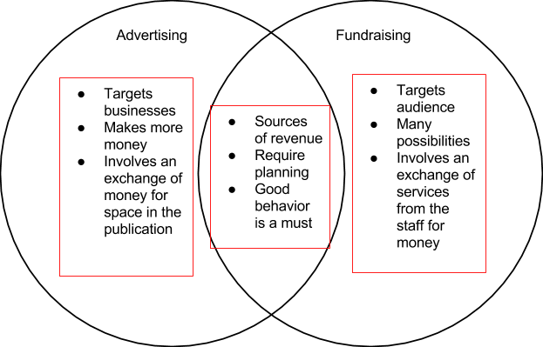

Section 4: Marketing Scenarios (6 points)

7. Consider the following scenarios and explain how you would respond to each.

- You have sent out a quarterly yearbook reminder to all of the students who have not yet purchased a book. You just received an email from a parent stating they will only purchase one book per student, per year. This family has five children currently at the high school, but have purchased a yearbook for only one of them. They would like you to remove their other children from the list. How do you respond?

Answers will vary, but should include a discussion of why the yearbook is valuable to all students and why a family should purchase a yearbook for each child.

- One of your reporters wrote an article that caused quite a stir in the community, including a lot of comments on your website, and now your principal wants you to take the website down, unless you can explain to him the value of keeping your website operational. What do you say?
Answers will vary, but should include a discussion of why this is not the principal’s decision, how this discussion is good, the staff’s commenting policy, and what they will do to limit disruption to the school environment.

