Name: ______________________________________ Date: _______________________

Publication Marketing Test

Directions: Complete the following questions about publication marketing. Each question is worth one point unless otherwise noted. (50 points total)

Section 1: Sales and Marketing Concepts (8 points)

Use at least THREE of the following words to explain how a publication should understand audience behavior and how to market to them effectively.

Incentives Preferences Choice Profit

Supply Demand Scarcity Market Audience

Section 2: Marketing with Social Media and Branding (16 points)

2. Explain how each of the following can be used to encourage reader interaction (2 points each)

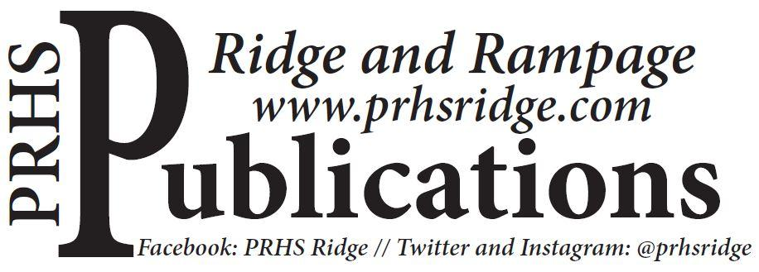

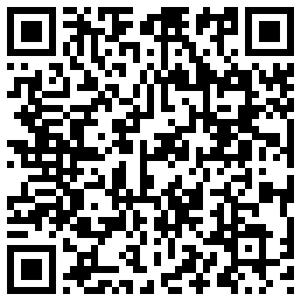
3. Describe THREE ways to use social media to market a publication. (6 points)

4. Describe THREE ways you can involve your audience with your publication as a way to improve your “brand” with them. (6 points)

Section 3: Money Matters (20 points)

5. Your publication is $2,000 in debt. Describe FOUR strategies you could use to get out of debt. (8 points)

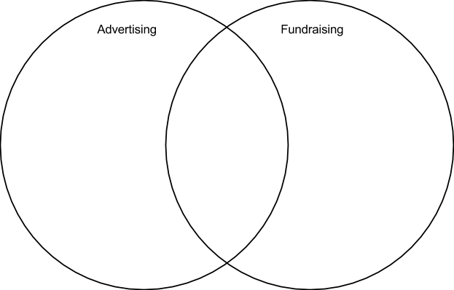

6. Complete the Venn diagram below to compare and contrast advertising and fundraising as sources of revenue. Include at least three bullets in each section of the diagram. (12 points)

Section 4: Marketing Scenarios (6 points)

7. Consider the following scenarios and explain how you would respond to each.

- You have sent out a quarterly yearbook reminder to all of the students who have not yet purchased a book. You just received an email from a parent stating they will only purchase one book per student, per year. This family has five children currently at the high school, but have purchased a yearbook for only one of them. They would like you to remove their other children from the list. How do you respond?

- One of your reporters wrote an article that caused quite a stir in the community, including a lot of comments on your website, and now your principal wants you to take the website down, unless you can explain to him the value of keeping your website operational. What do you say?

