Rules for Writing Photo Captions

A caption is the block of text that accompanies a photo in a print or online form.

There are three parts of a caption:
- In the first sentence, explain what is happening in the photo in present tense. Answer the 5 Ws.
- The second sentence is often past tense and gives background information about the photo or the situation. The focus should be on giving interesting information to readers and telling a story.
- The third sentence should give a quote from a witness or someone who was involved in the activity.

Most newspapers follow guidelines “a” and “b”
Online captions will sometimes mimic newspapers but often be shorter (“a” only)

When it comes to yearbook, many different types of captions exist.
Identification captions only list the names of the individuals in the photo
Summary captions generally follow guideline “A”
Expanded captions follow guidelines “A” and “B”
Quote captions follow guidelines “A,” “B” and “C”

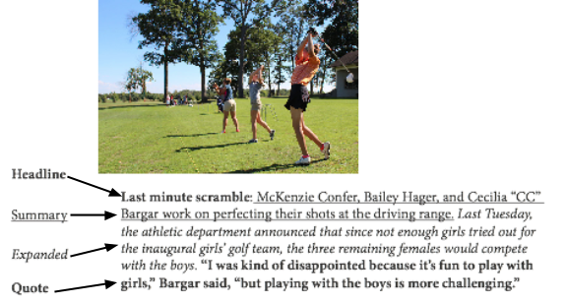

Other tips:
- DO identify everyone fully by first name, last name, year in school, or some other identifying information (unless the group is very large)
- DO NOT state the obvious
- DO NOT write question captions or use the word “pictured.”
- Some newspapers and yearbooks also headline their photos with a 1-3 word headline prior to the caption.
Evaluate these sample captions. What do you like? What can be improved? Is there a venue (newspaper, yearbook, etc?) in which the captions work well?
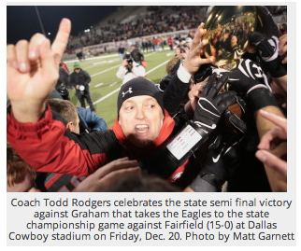

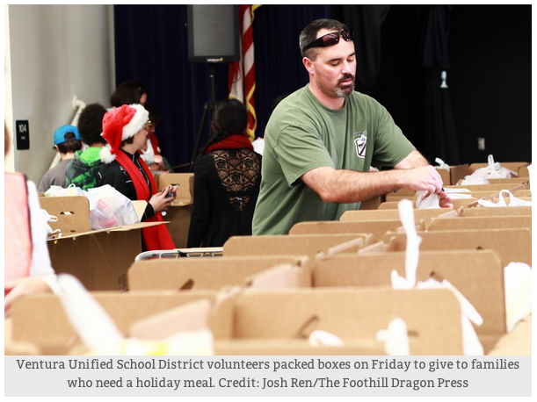
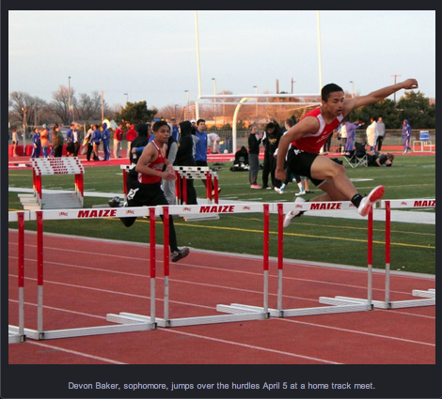

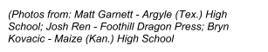

Use the information below to write a traditional three-sentence yearbook caption.
Note: The sample information is not necessarily “correct” in this case, but it is generally the photographer’s job to collect information to facilitate writing captions.

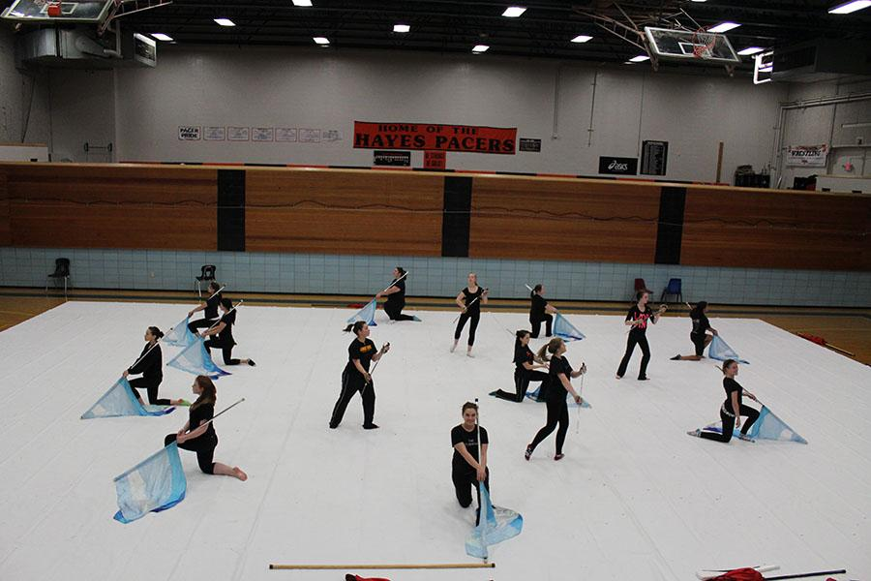
Who: Hayes High School’s winter guard
What: practice
Where: auxiliary gymnasium at Hayes
Why: to prepare for upcoming competition
When: Tuesday, November 19

Write an expanded yearbook caption with quote:

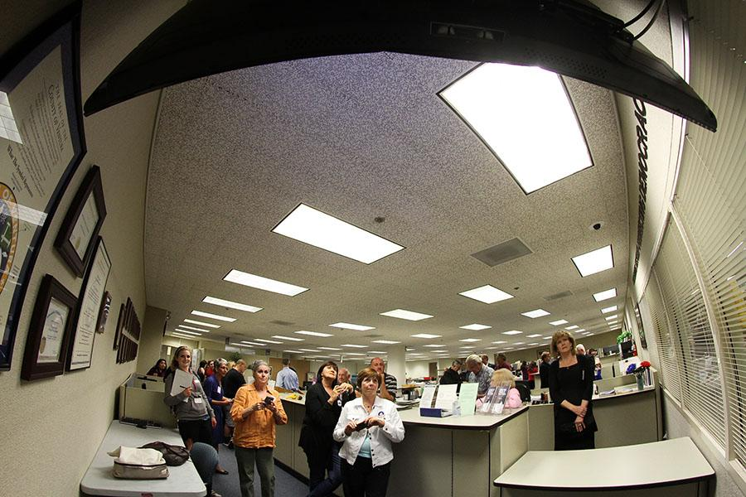

Who: voters in Ventura County
What: watch the television monitor
Where: Ventura County Government Center
Why: to see results as they get tabulated
When: November 6 (election night)

Write a newspaper caption:

(Photos by: Bushra Ghafoor - R.B. Hayes High School; Aysen Tan - Foothill Dragon Press)

