Photojournalism Exam KEY Name ________________________

Part 1: Match the photography term with its definition.
__Z__ 1. Framing A. Composition technique by which lines direct viewers to the subject
__U__ 2. Metering B. Photo with the background cut away, leaving only subject
__L__ 3. Burn C. Color correction tool that allows for very specific areas of correction
__Y__ 4. ISO D. Length of time a camera allows light into the camera’s eye
__N__ 5. Manual mode E. Special file type that allows for advanced photo editing
__I__ 6. Levels F. Composition technique using a repeating element or pattern
__Q__ 7. Rule of thirds G. Natural adjustment camera makes to adjust for different light sources
__G___ 8. White balance H. Multiple photos working together to deliver one cohesive message
__R__ 9. Dodge I. Color correction tool with all bright or dark areas are controlled at once
__P__ 10. Aperture J. A general term for the amount of light that reaches a camera’s lens
__A__ 11. Leading lines K. Photo angle from extreme high vantage point
__S__ 12. Focal point L. Editing tool that allows specific areas of a photo to be made darker
__E__ 13. RAW M. Composition rule; the photographer is above or below subject
__W__ 14. Selective focus N. Camera setting where the photographer controls all aspects
__D__ 15. Shutter speed O. Artificial light added to a photo
__H__ 16. Photo story P. The amount of light that enters through the camera’s eye
__T__ 17. Worm’s eye view Q. Composition rule; subject is not centered in the photo
__X__ 18. Cropping R. Editing tool that allows specific areas of a photo to be made lighter
__M__ 19. Angles S. Photo’s subject or center of interest
__V__ 20. JPEG T. Photo taken from extreme low vantage point
__J__ 21. Exposure U. How much of the viewfinder the camera uses to determine exposure
__O__ 22. Flash V. File type that is most common for saving edited photographs
__B__ 23. Cutout W. Composition rule; subject is clear while other images appear blurry
__F__ 24. Repetition X. The removal of outer parts of an image to improve the overall photo
__C__ 25. Curves Y. Camera’s sensitivity to light
__K__ 26. Bird’s eye view Z. Composition technique in which elements frame the subject

Part 2: Match the individual with the task for which he/she is famous.
__H___ 27. Louis Daguerre A. Coined the term “photojournalism”
__G___ 28. Carol Szathmari B. Civil War photographer accused of moving
bodies
__I___ 29. George Eastman C. Published first illustrated book
__A___ 30. Frank Luther Mott D. Took pictures of a galloping horse
__E___ 31. Mathew Brady E. Lincoln gave him permission to photograph
the Civil War
__B___ 32. Alexander Gardner F. Photographer of famous “Migrant Mother”
__F___ 33. Dorothea Lange G. First photojournalist; shot pics of Crimean War
__D___ 34. Eadweard Muybridge H. Created an exposure in 30 seconds
__C___ 35. William Henry Fox Talbot I. Developed the first roll of film for a camera

Part 3: Answer each of the following questions on a separate sheet of paper: (2 pts each)
36-37. List and explain two tips for taking better portraits.
Possible answers: shoot photos outside, move away from a wall, avoid flash, lean sideways against a wall, use subject’s natural environment, use light from windows

38-39. Describe action versus reaction when it comes to taking sports photos. Why does a photographer need both?
Action: what is happening in the sporting event; Reaction: the responses and emotions of those who are at the event. The photographer needs both because action photos tend to all look the same, while reaction photos tell a better (more personal) story.

40-41. Describe how shutter speed affects a photograph. What does a photo taken with a slow shutter speed look like compared to a photo taken with a fast shutter speed?
A fast shutter speed freezes movement so you get crisp, clear images; a slower shutter speed blurs movement.

42-43. Explain the white balance setting. Describe how you might decide which setting to use.
The white balance setting allows you to pick what type of light you are photographing in; that way the camera automatically adjusts for it. You might pick “fluorescent” setting if you are under that type of light to keep photos from looking harsh.

44-45. What is the purpose of taking photos in RAW form instead of JPEG?
RAW photos are more time-intensive, because they must be edited and saved as JPEG to be used in a design program. However, they allow for more extensive editing than JPEGs.

46-47. Put the following items in order from least effective to most effective when it comes to color correction, then explain: curves, brightness/contrast, levels.
Brightness/contrast: adjust all of the color in the whole photo
Levels: adjusts all of the darks, lights, or midtones at one time
Curves: adjusts very specific areas or colors within a photo

48-49. Compare and contrast a cropped photo versus a cutout.
A cropped photo has parts of the background cut away, but it still has some background. It has edges or a four-sided frame. A cutout has the entire background cut away and only the subject remains.

50-51. Imagine you are trying to take a photo in a dark hallway of the school. What are two tips you could use to improve the quality of your photo?
You could adjust the white balance, increase the exposure, raise the ISO. (Students should NOT say “use flash.”)

52-53. Name and explain two ethical considerations you think are important for photographers to follow.
Answers vary.

54-55. Name two common photo manipulations that can get a photojournalist in trouble.
Flipping a photo, adding or taking away something in a photo, or adjusting the color to an extreme amount.

56-57. Describe two different ways that a photographer might choose to capture motion.
1) Use a fast shutter speed to freeze the entire photo. 2) Use a slow shutter speed to blur the entire image. 3) Freeze the subject but blur the rest of the image (using a panning technique). 4) Use a tripod and a medium shutter speed to blur a fast-moving subject but freeze the rest of the image.

58-59. In what ways can the visual content of a newspaper change the overall content of the newspaper for a viewer?
Photos can distort a story or cause bias for a reader prior to reading the story.

60-61.Explain the difference between news and features in photojournalism. How should a photojournalist prepare for these different types of photos?
News photos capture an event and are typically more straightforward, whereas features photos capture more “slice of life” circumstances and allow for more artistic freedom. A photojournalist needs to educate himself about the situation ahead of time and plan his desired images.

Part 4: For each of the following photos, write a caption with headline that follows the guidelines given. Answers will vary.
62-63: Newspaper caption.  Not just kissing babies: Local politician Tim Allen addresses his supporters during last Tuesday’s campaign stop in Tulsa. Allen will face off against Democratic candidate Bob Roeder in next week’s election.  (McKinney High School Publications) | 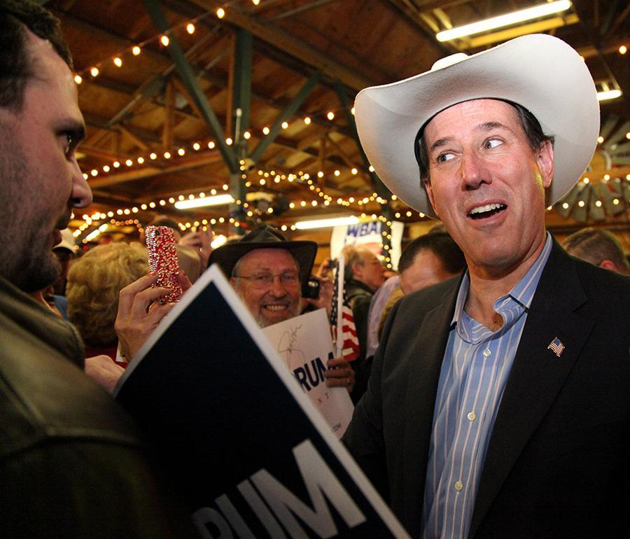
64-66: Yearbook extended caption w/ quote.
Taking the lead: On Sept. 13, senior captain Regan Simone practices the breaststroke during a morning swim practice. Simone qualified for States for the third time in her high school career and earned a top 10 finish in the 100M. “The entire team worked hard this year to improve, and I’m grateful that I had the chance to lead us,” Simone said.

(Hannah Kunz - Westlake High School)
67-68: Yearbook summary caption.  Face the day: Students in Mrs. Kronkowski’s physical education class touch up their makeup before leaving the locker rooms for lunch. After complaints from students and an editorial in the student newspaper, the P.E. department made a conscious effort to increase the amount of time students were given at the end of each class.  (Lore Staff) | 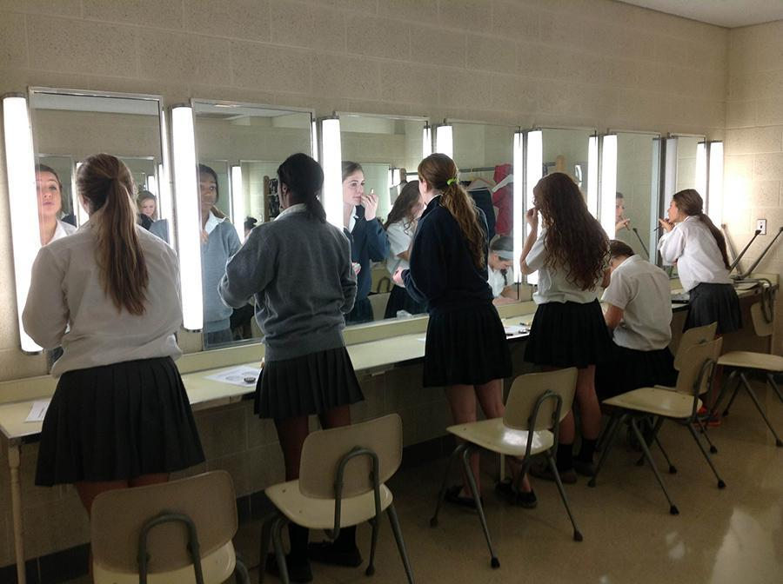

Part 5: For each of the following photos, name/explain one composition rule (strong subject, framing, angle, leading lines, rule of thirds, selective focus, repetition) demonstrated. Do not use any term more than once. Answers may vary.
69-70:
Angle (worm’s eye view), because the photographer is clearly below the subjects.

(Bryant High School Publications)
71-72:  Repetition - the repetition of the band members makes the variation (the boy in the football jersey) stand out.  (McKinney High School Publications) | 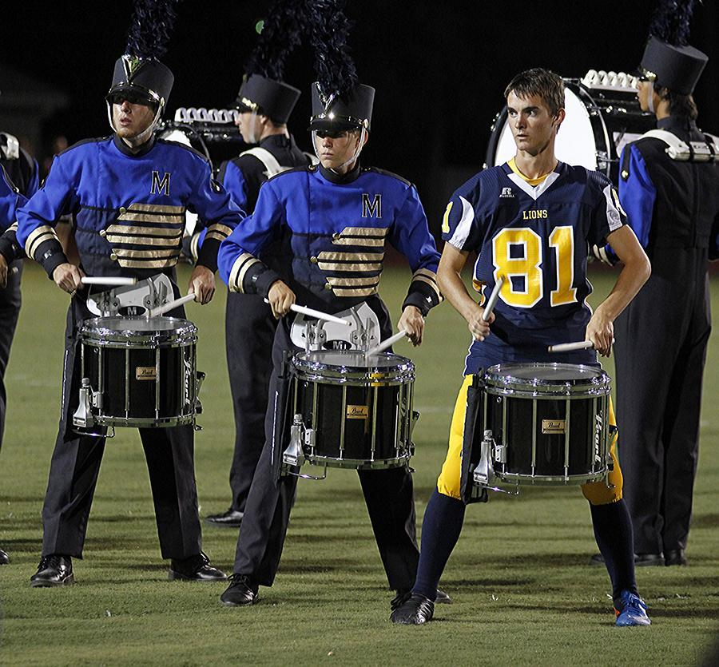
73-74:  Focal point. The minimal background make the subject stand out more prominently in the photo.  (McKinney High School Publications) | 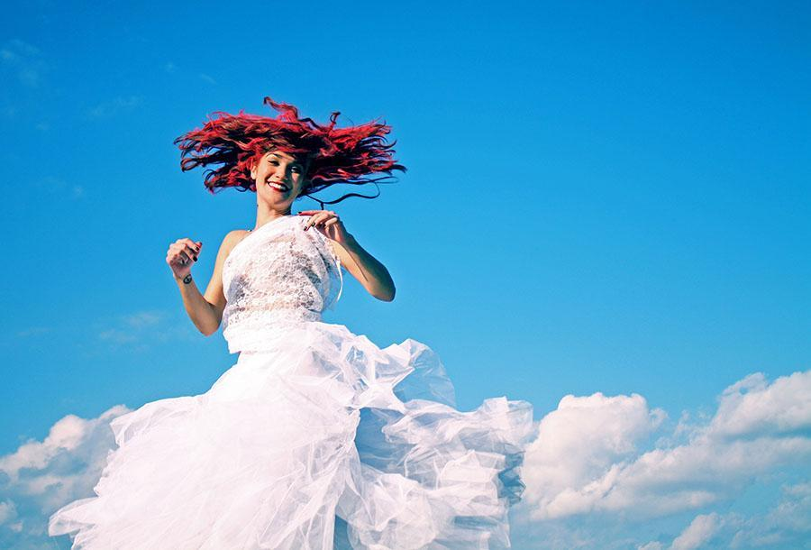
75-76:  Rule of thirds. The subject of the photo appears in the top right corner rather than the middle, which emphasizes the wall and the artwork more.  (Peri Kincaid - Westlake High School) | 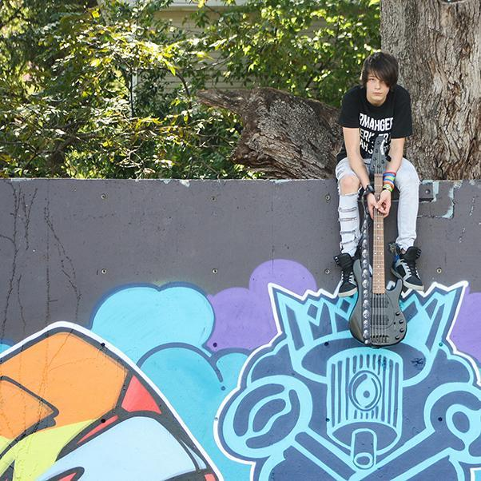
77-78:  Framing - the boys bowing down to the girl directs the viewer’s attention very clearly to the subject.  (McKinney High School Publications) | 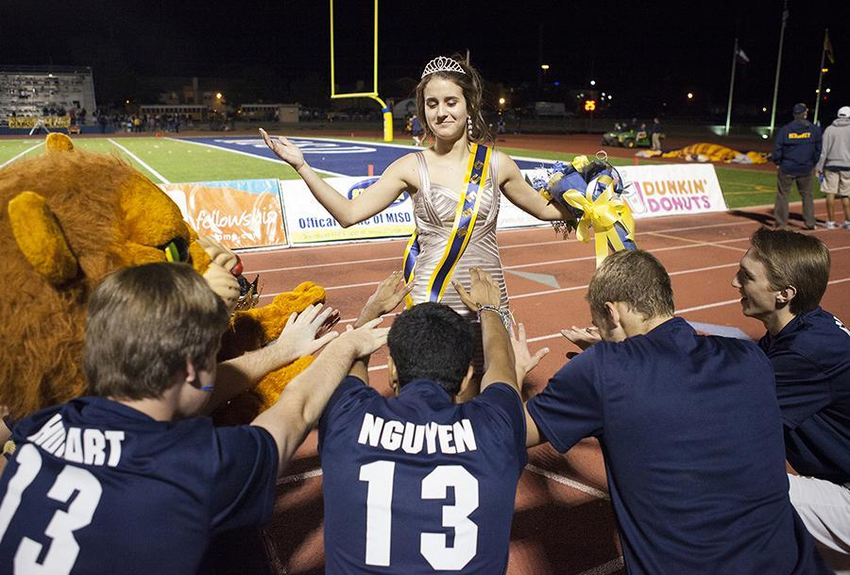

Part 6: Name one aspect of exposure (ISO, aperture, white balance, shutter speed, metering, flash) the photographer uses in the following photos and explain how it is done well. Answers may vary.
79-81:  White balance - Use a “sun” setting in the white balance adjustment to keep your subject from being washed out by the direct sunlight.  (Bryant High School Publications) | 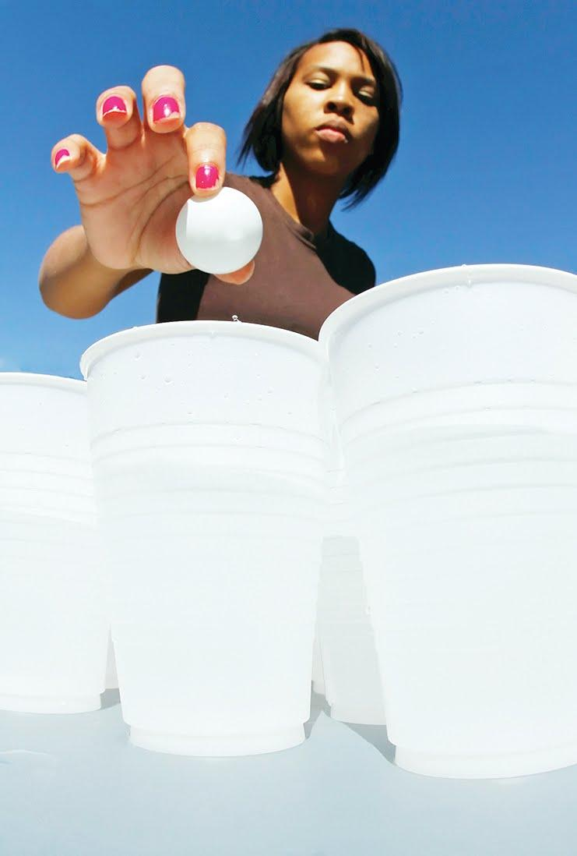
82-84:
Shutter speed - a very quick shutter speed here allows for the light from the window to reach the lens while still keeping the darker hallway from getting too exposed in the image.

(Bryant High School Publications)
85-87:
Aperture - The photographer set a very low aperture in order to get the dancer’s toes in sharp focus but keep the rest a little blurry.

(Bryant High School Publications)
88-90:  Shutter speed - the photographer here set a very fast shutter speed to freeze this very quick movement.  (Casey Simmons - Westlake High School) | 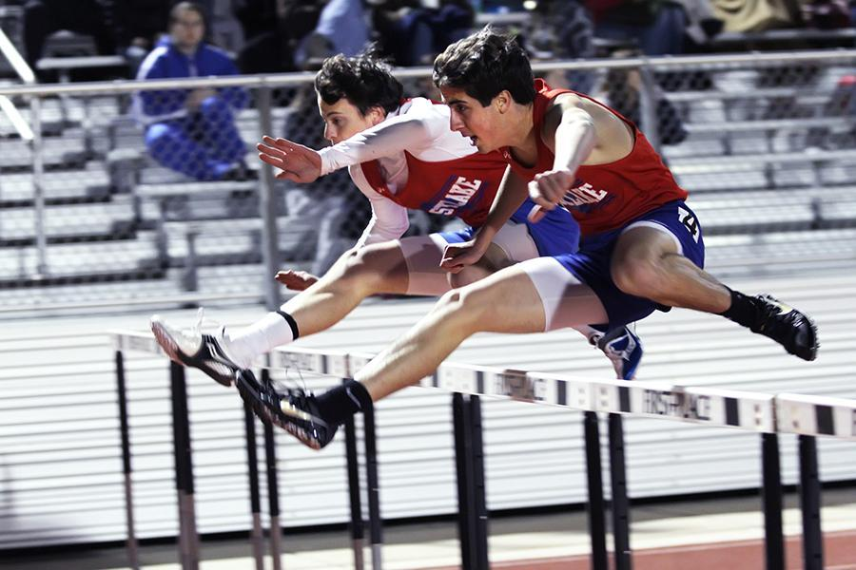

Part 7: Evaluate the photo story shown on the following page. How well do you think the photographer captures the essence of the story? Be specific and provide evidence to support your opinion. (10 points)
Answers will vary. Students may mention the emotion created by the images, the beginning-to-end feel of the story, etc.

