Quiz - Photojournalism Name: ____________________________
Score: _____ / 45

Part 1: Matching - History of Photojournalism
_____ 1. George Eastman A. Published first illustrated book
_____ 2. Eadweard Muybridge B. Created an exposure in 30 seconds
_____ 3. Dorothea Lange C. First photojournalist - pics of Crimean War
_____ 4. Alexander Gardner D. Photographer of famous “Migrant Mother”
_____ 5. Mathew Brady E. Lincoln gave him permission to photograph
the Civil War
_____ 6. Louis Daguerre F. Coined the term “photojournalism”
_____ 7. William Henry Fox Talbot G. Developed the first roll film for a camera
_____ 8. Carol Szathmari H. Civil War photographer accused of moving
bodies
_____ 9. Frank Luther Mott I. Took pictures of a galloping horse

Part 2: Match the exposure aspect with the definition (1 pt each)
_____ 11. ISO | A. the length of time that a camera allows light into the camera’s eye
_____ 12. Exposure | B. the amount of light that enters through the camera’s eye
_____ 13. Shutter Speed | C. a general term for the amount of light that reaches a camera’s lens
_____ 14. Aperture | D. the camera’s sensitivity to light

Part 3: Match the photo editing term with the definition. (1 pt each)
_____ 15. Cropping A. A color adjustment that accounts for darks, lights, and midtones
_____ 16. Levels B. Removing the exterior edge(s) of a photo
_____ 17. Curves C. An image where the background has been deleted
_____ 18. Dodging D. The process of making a photo lighter
_____ 19. Burning E. A process that allows for fine-tune color adjustment
_____ 20. Cutout F. The process of making a photo darker

Part 4: Short Answer. (3 pts each)
21. What is the most important technological development in photojournalism’s history? Be as specific as possible and defend your answer.

22. Explain what it means to take photos in “Shutter Priority.” What does the camera decide for the photographer, and what settings does the photographer still need to manipulate on his own?

23. Describe a scenario when a photographer might want to use a very high ISO and a scenario when a photographer might want to use a very low ISO.

24. What is resolution? In what instances might a photographer save a photo at a high resolution, and when might a photographer save a photo at a lower resolution?

25. Describe the difference between RGB, CMYK, and grayscale and when a photographer would save a photo in each mode.

Part 4: Photo Composition & Caption Writing. Write the most obvious photo composition rule for each photo (1 pt each). Explain WHY the photo fits that rule (1 pt each). Then, write captions/headlines for each photo (3 pts each).
Photo Composition Rule:  Explanation:  Headline/Photo Caption:  (The PIX Yearbook - Little Rock, Arkansas) | 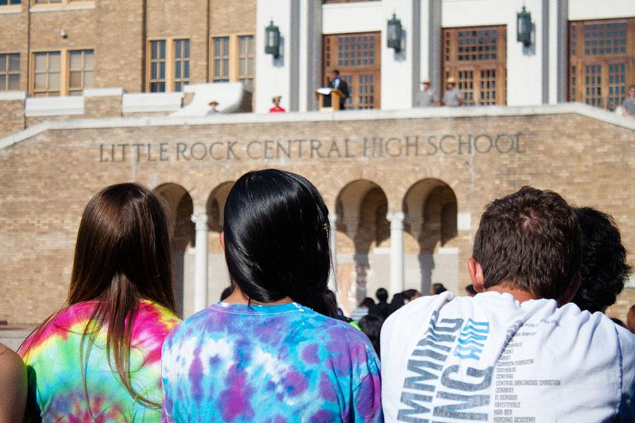

Photo Composition Rule:  Explanation:  Headline/Photo Caption:  (The PIX Yearbook - Little Rock, Arkansas) | 