Quiz - Photojournalism Name: ____________________________
Score: _____ / 54

Part 1: Matching - History of Photojournalism
__G__ 1. George Eastman A. Published first illustrated book
__I__ 2. Eadweard Muybridge B. Created an exposure in 30 seconds
__D__ 3. Dorothea Lange C. First photojournalist - pics of Crimean War
__H__ 4. Alexander Gardner D. Photographer of famous “Migrant Mother”
__E__ 5. Mathew Brady E. Lincoln gave him permission to photograph
the Civil War
__B__ 6. Louis Daguerre F. Coined the term “photojournalism”
__A__ 7. William Henry Fox Talbot G. Developed the first roll film for a camera
__C__ 8. Carol Szathmari H. Civil War photographer accused of moving
bodies
__F__ 9. Frank Luther Mott I. Took pictures of a galloping horse

Part 2: Match the exposure aspect with the definition (1 pt each)
__D___ 11. ISO | A. the length of time that a camera allows light into the camera’s eye
__C___ 12. Exposure | B. the amount of light that enters through the camera’s eye
__A___ 13. Shutter Speed | C. a general term for the amount of light that reaches a camera’s lens
__B___ 14. Aperture | D. the camera’s sensitivity to light

Part 3: Match the photo editing term with the definition. (1 pt each)
__B___ 15. Cropping A. A color adjustment that accounts for darks, lights, and midtones
__A___ 16. Levels B. Removing the exterior edge(s) of a photo
__E___ 17. Curves C. An image where the background has been deleted
__D___ 18. Dodging D. The process of making a photo lighter
__F___ 19. Burning E. A process that allows for fine-tune color adjustment
__C___ 20. Cutout F. The process of making a photo darker

Part 4: Short Answer. (3 pts each)
21. What is the most important technological development in photojournalism’s history? Be as specific as possible and defend your answer.
(Answers vary)
22. Explain what it means to take photos in “Shutter Priority.” What does the camera decide for the photographer, and what settings does the photographer still need to manipulate on his own?
In Shutter Priority, the camera will automatically adjust Aperture to account for the settings that the photographer chooses for Shutter Speed. The photographer must also still choose White Balance and ISO.

23. Describe a scenario when a photographer might want to use a very high ISO and a scenario when a photographer might want to use a very low ISO.
High ISO: Gymnasium, darkened classroom, etc.
Low ISO: Bright, direct sunlight

24. What is resolution? In what instances might a photographer save a photo at a high resolution, and when might a photographer save a photo at a lower resolution?
Resolution is the number of pixels per square inch for which the camera records individual data. The higher the resolution, the higher quality the photo (and generally, the larger it can be printed). Higher resolutions should be used for photos that appear in print publications, and lower resolutions should be used online to minimize file size.

25. Describe the difference between RGB, CMYK, and grayscale and when a photographer would save a photo in each mode.
RGB - saves color information for “reds, greens, and blues.” These are used for online photos.
CMYK - saves color information for “cyan, magenta, yellow, and black.” These are used for print photos.
Grayscale - discards all color information; photographers use this for black-and-white pages of print publications.

26. List and explain two tips that photographers should use for taking better portraits.
Take portraits outside, move away from wall, avoid flash, lean sideways against a wall, use a subject’s natural environment, use light from windows

27. Describe what a photographer means by “action v. reaction.” Why is this balance important?
Action - what is happening in the sports event (the plays, the shots, etc)
Reaction - spectators’/coaches’/students’/players’ reactions to what is happening in the event
Balance is important because the reaction tells the story more than the action.

28. Name one practice that we discussed in class that is considered unethical when it comes to photo manipulation. Explain why.
Adding something to the photo; taking away something from the photo; flipping; severe color adjustments. Explanations will vary.

Part 4: Photo Composition & Caption Writing. Write the most obvious photo composition rule for each photo (1 pt each). Explain WHY the photo fits that rule (1 pt each). Then, write captions/headlines for each photo (3 pts each).

Photo Composition Rule: selective focus  Explanation: the heads of the students are in focus, but the speaker on the steps is out of focus.  Yearbook expanded caption: A Call to Vote: Juniors and seniors sit on the quad as Assistant Principal Patrick Ferguson introduces a guest speaker. The speaker, a visiting local politician, urged high school students to register to vote as soon as they become eligible.  (The PIX Yearbook - Little Rock, Arkansas) | 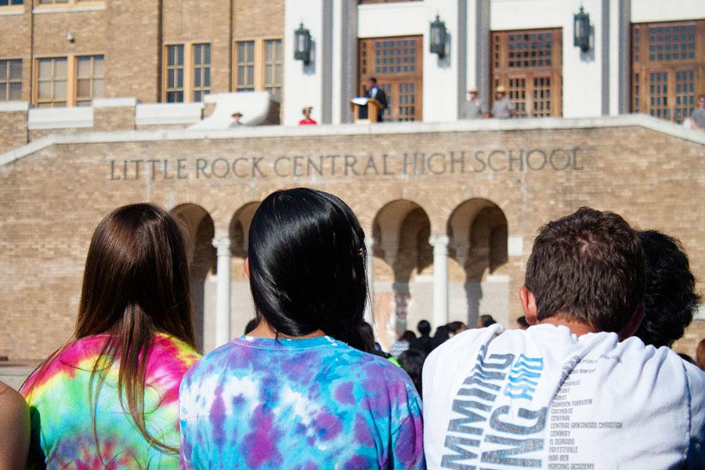

Photo Composition Rule: framing  Explanation: the science beakers direct the viewer’s attention to the girl’s face and away from the rest of the photo.  Newspaper caption: No boys allowed: Junior Skyler Parker finishes a lab about the importance of catalysts in chemical reactions. Parker is participating in an all-female after-school science program sponsored by Exxon-Mobile.  (The PIX Yearbook - Little Rock, Arkansas) | 