Basics of Photojournalism Quiz Name ______________________________________

1. The concept of “angle” in photo composition is broad. Name and explain two specific angles we discussed in class. (2 pts)
A) Bird’s eye view - photo is taken from extreme high vantage point
B) Worm’s eye view - photo is taken from extreme low vantage point, often looking up

2. A photo can be beautiful and follow composition techniques, but what else must it do to be effective? Explain. (2 pts)
A photo must also tell a story. It needs to capture specific details about the event surrounding the photo to create an emotional connection with the reader.

3. List and explain two differences between News and Feature photos. (4 pts)
News Photos | Feature Photos
- Taken at a specific event  - Represent something concrete that happened  - Inform viewers  - Have news value | - Capture a unique moment in the culture  - Represent a “slice of life” or issue  - Elicit emotional response  - Have human interest

4. Pretend that you are a yearbook photographer who has been assigned to take feature photos at prom. Give three different scenarios that you might take photos of, beyond the “obvious” or stereotypical photos. (3 pts)
Answers will vary, but students might suggest photos of different fashion angles, getting ready for prom, couples vs. friends, or the students who choose not to dance, etc.

5. For each composition error listed below, match the term with the description. (1 pt each)
___ C __ 1. bright spot/hole A. subjects’ arms/legs aren’t entirely in the photo
___ D __ 2. intrusion B. subjects move toward an edge rather than the middle
___ A __ 3. unintentional cropping C. exceptionally light or dark areas in a photo
___ B __ 4. directional error D. parts of objects appear on the edge of the photo
___ E __ 5. merger E. two objects appear to be joined together

6. For each photo on the following pages, write the most obvious photo composition technique - do not use any rule more than twice (1 pt each). Explain WHY the photo fits that rule (1 pt each). Then, write a caption or headline as indicated. (3 pts each)
Photo composition rule: thirds OR leading lines  Explanation: The subject is off center in the photo OR the lines created by the gun barrels and the yellow line on the floor direct the viewer’s attention to other areas of the photo.  Yearbook summary caption: Taking aim: Sophomore Ben Gee takes aim at a practice target during his basic shooting class Nov. 12. The class is part of a new initiative to develop a stronger elective program.  (Kylie Stamper - Maize (Kan.) High School) | 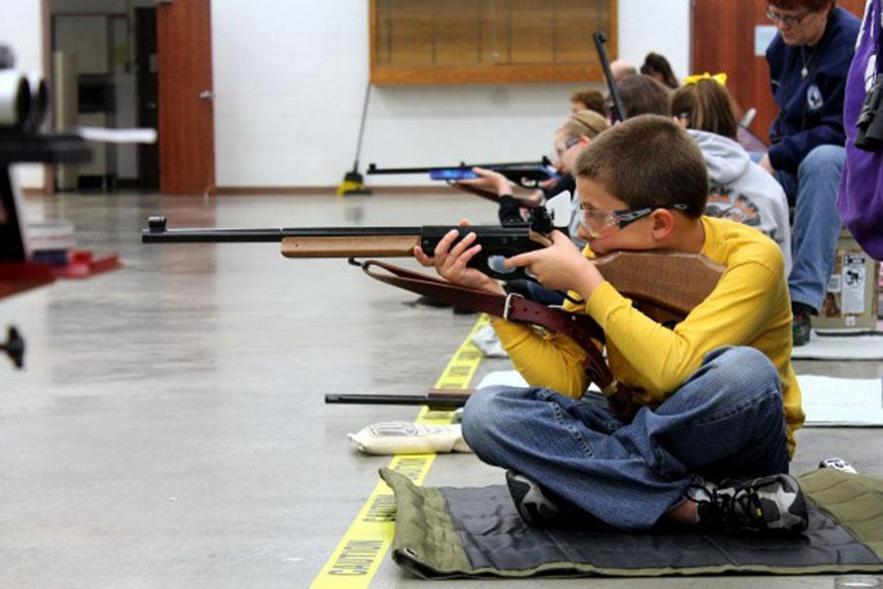

Photo composition rule: strong subject OR framing

Explanation: The subject of the photo takes up most of the photo OR the adult’s face creates a frame for the child’s face.

Yearbook expanded caption: The Face of Hope: Preschool student Riley Parker shows off her face painting during the annual May Day picnic at Thomas Jefferson High School. Student council members volunteered to paint faces as a way to raise money to provide school supplies to struggling families.

(The PIX Yearbook - Little Rock, Arkansas)

Photo composition rule: angle (worm’s eye view) OR thirds  Explanation: The picture is taken from an extreme low angle OR the subject is located in the bottom corner of the photo.  Newspaper caption: Height of controversy: Senior Jennifer Rodgers participates in one last lift with the cheerleading squad. The team members were recently told that the squad would be disbanding due to administrators’ concerns about weight requirements.  (The PIX Yearbook - Little Rock, Arkansas) | 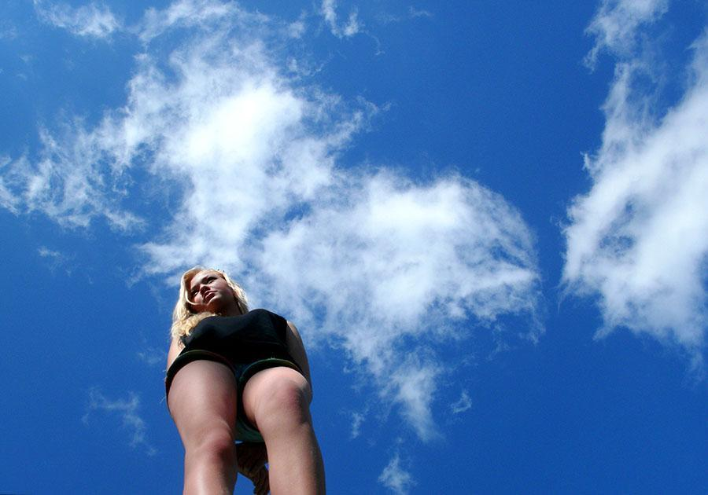

Photo composition rule: framing  Explanation: The science beakers direct the viewer’s attention to the girl’s face and away from the rest of the photo.  Newspaper caption: No boys allowed: Junior Skyler Parker finishes a lab about the importance of catalysts in chemical reactions. Parker was one of 17 participants in an all-female after-school science program sponsored by Exxon-Mobile.  (The PIX Yearbook - Little Rock, Arkansas) | 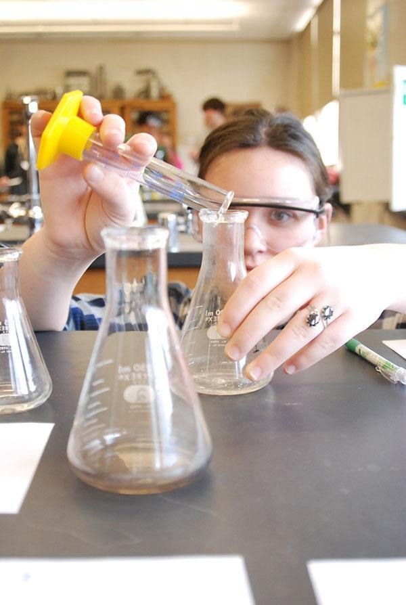

Photo composition rule: repetition OR thirds  Explanation: The repetition of the yellow uniforms makes the subject of the photo stand out more OR the subject is located on the right side of the photo  Yearbook expanded caption w/ quote: Breath of fresh air: Sophomore Samantha Spark takes a breath before beginning her solo dance performance in the halftime show. Spark decided to try out for the dance team after a knee injury prohibited her from continuing gymnastics. “It’s been a completely different experience than I expected,” Spark said, “but one that I know I’ll never forget.”  (The PIX Yearbook - Little Rock, Arkansas) | 