Basics of Photojournalism Quiz Name ______________________________________

1. The concept of “angle” in photo composition is broad. Name and explain two specific angles we discussed in class. (2 pts)
A)

B)

2. A photo can be beautiful and follow composition rules, but what else must it do to be effective? Explain.
(2 pts)

3. List and explain two differences between news and feature photos. (4 pts)
news photos | feature photos

4. Imagine you are a photographer who has been assigned to take feature photos at prom. Give three different scenarios that you might take photos of, beyond the “obvious” or stereotypical shots. (3 pts)

5. For each composition error listed below, match the term with the description. (1 pt each)
_____ 1. bright spot/hole A. subjects’ arms/legs aren’t entirely in the photo
_____ 2. intrusion B. subjects move toward an edge rather than the middle
_____ 3. unintentional cropping C. exceptionally light or dark areas in a photo
_____ 4. directional error D. parts of objects appear on the edge of the photo
_____ 5. merger E. two objects appear to be joined together

6. For each photo on the following pages, write the most obvious photo composition technique – do not use any more than TWICE (1 pt each). Explain WHY the photo fits that rule (1 pt each). Then, write a caption or headline as indicated. (3 pts each)
Photo composition technique:  Explanation:  Yearbook summary caption:  (Kylie Stamper - Maize (Kan.) High School) | 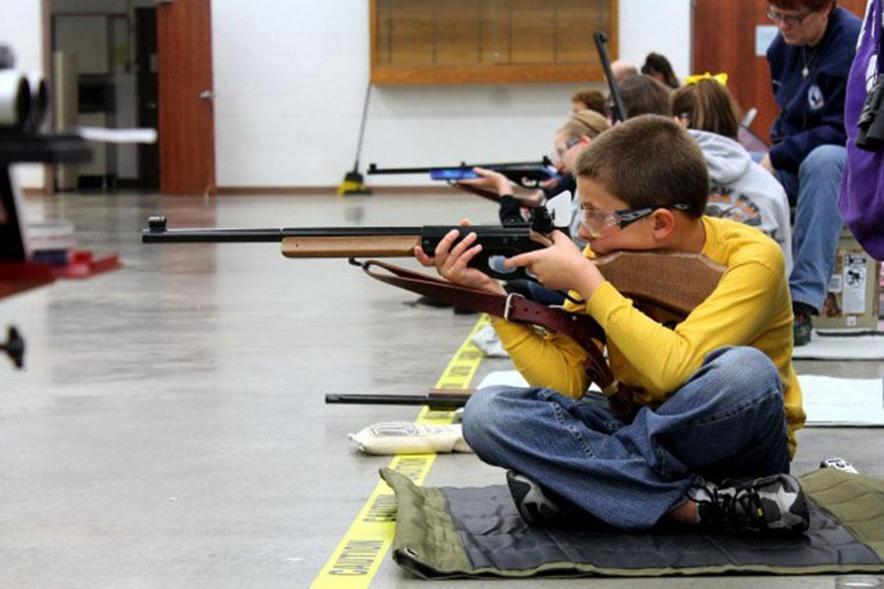

Photo composition rule:

Explanation:

Yearbook expanded caption:

(The PIX Yearbook - Little Rock, Arkansas)

Photo composition rule:

Explanation:

Newspaper caption:

(The PIX Yearbook - Little Rock, Arkansas)

Photo composition rule:

Explanation:

Newspaper caption:

(The PIX Yearbook - Little Rock, Arkansas)

Photo composition rule:  Explanation:  Yearbook expanded caption with quote:  (The PIX Yearbook - Little Rock, Arkansas) | 