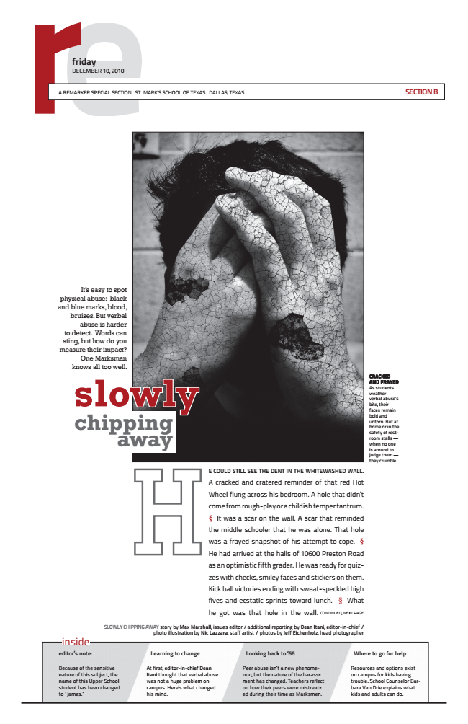
r
a remarker special section st. mark’s school of texas dallas, texas
e friday DECEMBER 10, 2010
It’s easy to spot physical abuse: black and blue marks, blood, bruises. But verbal abuse is harder to detect. Words can sting, but how do you measure their impact? One Marksman knows slowly
all too well.
CRACKED AND FRAYED As students weather verbal abuse’s bite, their chipping away
H
faces remain bold and untorn. But at home or in the safety of rest- room stalls — when no one is around to judge them — they crumble.
CONTINUED, NEXT PAGE
slowly chiPPing away story by Max Marshall, issues editor / additional reporting by dean itani, editor-in-chief / inside
photo illustration by nic lazzara, staff artist / photos by Jeff eichenholz, head photographer
editor’s note: learning to change looking back to ‘66 where to go for help Because of the sensitive nature of this subject, the name of this Upper School student has been changed to “James.’
At first, editor-in-chief dean
Peer abuse isn’t a new phenome- itani thought that verbal abuse
non, but the nature of the harass- was not a huge problem on
ment has changed. Teachers reflect campus. Here’s what changed
on how their peers were mistreat- his mind.
ed during their time as Marksmen.
Resources and options exist on campus for kids having trouble. School Counselor Bar- bara Van Drie explains what kids and adults can do.
e could still see the dent in the whitewashed wall. A cracked and cratered reminder of that red Hot Wheel flung across his bedroom. A hole that didn’t come from rough-play or a childish temper tantrum. § It was a scar on the wall. A scar that reminded the middle schooler that he was alone. That hole was a frayed snapshot of his attempt to cope. § He had arrived at the halls of 10600 Preston Road as an optimistic fifth grader. He was ready for quiz- zes with checks, smiley faces and stickers on them. Kick ball victories ending with sweat-speckled high fives and ecstatic sprints toward lunch. § What he got was that hole in the wall.
section B

