All answers are from SPLC’s FERPA Facts log

Scenario 1:

It’s early September and your senior friends are starting their college applications. According to recent news reports, a rash of crimes have occurred at State University, which is the university closest geographically to your student body. You wonder about the overall campus crime rates and decide to write an article. You request the crime statistics of all the public colleges and universities from your state. All but one complies — State University. After getting ignored for three weeks, you finally hear back from the campus safety official, who claims the records are protected by FERPA.

What do you do?

Scenario 1 answer:

USC claims number of rape expulsions is "private"

The way colleges investigate and punish (or don’t punish) sexual assault is under a national microscope, with the U.S. Department of Education opening Title IX sex discrimination cases against schools accused of inadequately responding to campus rapes. At the University of Southern California, several students have come forward to say they felt victimized a second time by a disciplinary system that imposes little-to-no penalty on student rapists. The university, reports ABC News, won’t say how rapists are being punished: “USC officials said students accused of rape had been expelled from the college in the past, but would not confirm the number of expulsions, citing privacy concerns.”

Source: ABC News, Students Turn to Feds for Action on Alleged Rapes (July 25, 2013)

SPLC Executive Director Frank LoMonte: The quote attributed to USC by ABC News doesn’t refer to FERPA by name; it just says “privacy.” But whether the college is relying on the federal educational privacy statute or the common law of privacy that exists under state law, the answer is the same: Nope.

Statistics simply are not confidential, either as a matter of the Family Educational Rights and Privacy Act or as a matter of state privacy law. The statement that “ten students were expelled in 2012” contains absolutely nothing traceable to an individual student that would compromise privacy.

In fact, Congress has gone quite a bit further and said that all information about disciplinary cases in which a person is found liable for conduct equating to a violent crime or sex crime is exempt from FERPA privacy — that’s everything, names included. Since FERPA says, in so many words, that even student names aren’t even confidential after a finding of fault is made, there is no good-faith privacy argument for withholding mere numerical totals.

Like many schools confronted with a demand for embarrassing information, USC’s concern is less for “student privacy” than for “we-screwed-up privacy.” Because the number that ABC News asked for is almost certainly scandalously close to zero.

We know this because, in the fall of 2013, Yale University admitted that none of the six people found liable for non-consensual sex during the first half of 2013 got expelled, and in fact only one received even a lengthy suspension. More commonly, the punishment for rape is some combination of “disciplinary probation,” sensitivity training, and/or a reprimand. (At the University of Colorado, one rapist’s punishment was an eight-month suspension and a $75 fine. That’s less than half what you’d pay at Colorado for parking in a handicapped space without a permit.)

USC is a private institution and doesn’t have to obey state open-records laws, but the college at least ought to be honest about it. USC can say how many students were expelled for sexual assault. It just won’t say. Those concerned about campus safety at USC ought to let their president know that “won’t” isn’t good enough.
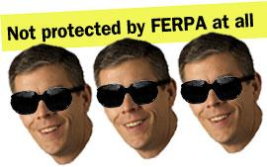

Scenario 2:
A melee happened on bus number 123. The school suspended several students because of the incident. Two students have been in the hospital for a week. Because you ride the bus, you know every bus has video cameras. You request a copy of the tape. The school denies the request because of FERPA.
What do you do?

Scenario 2 answer:

Ohio school district says school bus cameras are protected by FERPA

In an interview explaining the Aurora school district’s bus safety procedures, Superintendent Russ Bennett told the Aurora Advocate that each school bus is outfitted with security cameras to record student activity. The recordings can be viewed by administrators in the event of an incident, he said, but not by members of the public because they are protected by FERPA, the Family Educational Rights and Privacy Act.

Source: Aurora Advocate, Bennett: Aurora school district has methods to deal with bad bus behavior (August 21, 2013)

SPLC Executive Director Frank LoMonte: I want you to take a good look at this school bus and tell me what you see.
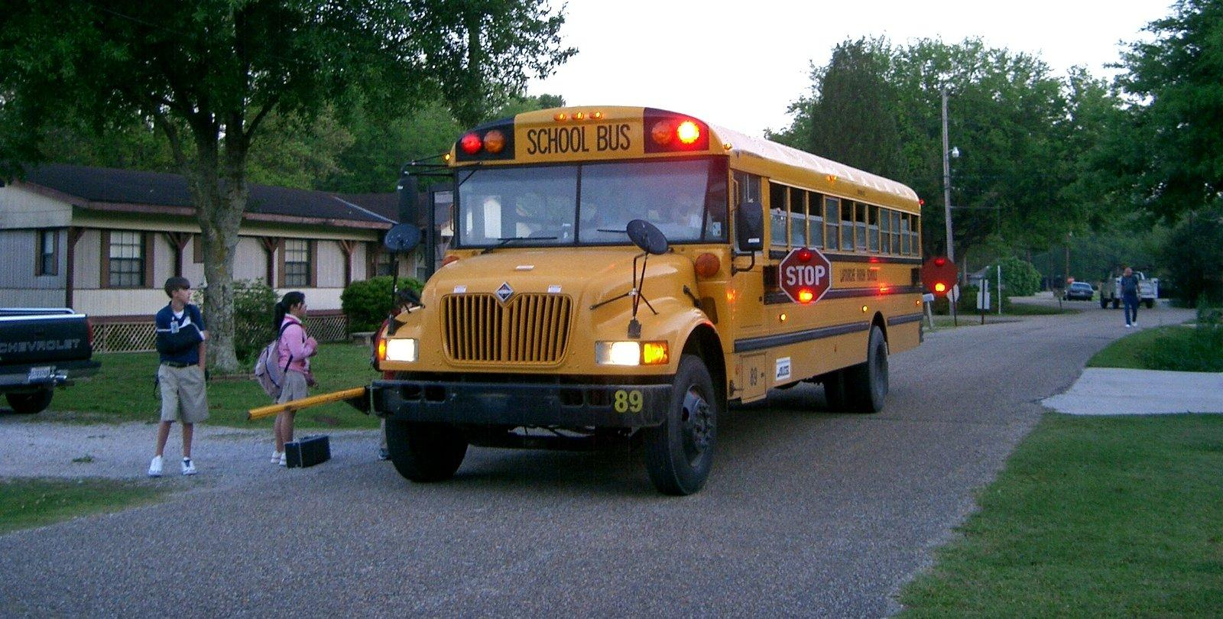

It’s not a trick question.

Windows, right? Lots and lots of transparent panes of glass.
Unless your mother makes you wear a bag over your head on the way to school (and if she does, then FERPA is the least of your worries), what you look like riding a bus is not the least bit confidential.

We know that school bus videos aren’t FERPA records for several reasons:
1) Because it’s stupid. If a document is a FERPA record, that triggers a set of affirmative legal rights, including the right to have an administrative hearing to challenge the accuracy of the record and to insert corrective information into the record so it isn’t misleading or incomplete. Are schools prepared to let parents splice clips of home movies into their surveillance videos?

2) Because the Department of Education has told us that what kids look like isn’t a secret. In a December 2003 opinion letter, the DOE’s chief FERPA enforcer said it’s not a privacy violation to let a visiting parent sit in on a class, even though the parent will see the faces and hear the voices of other people’s children: “FERPA does not protect the confidentiality of information in general; rather, FERPA applies to the disclosure of tangible records and of information derived from tangible records.”

In other words, unless the driver is reading kids’ report cards aloud while driving (and if that’s happening, we all need a look at that video), it’s not a privacy violation to see what goes on inside of a bus.

3) Because the courts have told us so.

In a common-sense application of both FERPA and state privacy law (school attorneys, you can Google “common sense” here, it might be worth a look), a state appellate court in Louisiana v. Mart ordered the release of a newsworthy recording of a school-bus brawl. (Note: the Mart case was partially overruled by a later case, on a point of procedure entirely unrelated to resolution of the open-records issue.) The judges in Mart, learned and scholarly people whose decades of intensive legal training familiarized them with the workings of windows, said:
[W]e find that the school board failed to demonstrate that the students had a reasonable expectation that their identity or their reaction to the crime would be shielded from public view. The students were riding on a public school bus and their actions were visible to all around them.

Similarly, a New York trial court concluded in 2005 that school surveillance videos aren’t confidential education records: “FERPA is not meant to apply to records, such as the videotape in question which was recorded to maintain the physical security and safety of the school building and which does not pertain to the educational performance of the students captured on this tape.”

Listening to a school lawyer try to explain why a school bus video is a FERPA record is like watching an especially slow-learning dog chase his own tail. The reasoning goes like this: “What the kids look like on the bus isn’t a secret education record. The video is the secret education record.”

But… but… but… it’s a video of what kids look like on the bus. Putting something non-secret onto a videotape doesn’t alchemically transform it into a secret.

We know this, because a Florida judge told the University of Florida that an otherwise-public Student Senate meeting was not imbued with magic FERPA dust when the university made a recording of it: “[B]ecause the meeting was open, it is hardly logical that a memorialization of it would be confidential.”

The slumbering U.S. Department of Education (where Secretary Arne Duncan astoundingly told reporters last week that it was news to him that schools might be overusing FERPA) was asked six-and-a-half years ago to issue guidance clarifying the FERPA status of school-bus videos. We’re still waiting. (In that request, a lawyer for school boards enlighteningly pointed out that schools don’t actually “maintain” the videos — which is a prerequisite for a record to be covered by FERPA — because they routinely erase and reuse them.)

Clarification is badly needed, because the Department unhelpfully muddied the issue in a February 2004 letter ruling that said a parent could not view a school surveillance tape of a fight if the tape showed any kids fighting other than her own. (Try saying with a straight face: “A parent does not have a right to know who beat up her child because we wouldn’t want to violate the attacker’s privacy.”)

We don’t need the Department of You Woke Me Up For That? to tell us the answer to this one. It’s as clear as a 10-year-old’s face smushed against a bus window.

Scenario 3:

You learn your school board is hosting a community-wide discussion on school safety. You know this topic is important, so you contact a writer to come along. Although you know the photos may not be exceptional, you’re eager to cover this topic and photograph the participants and discussion. Upon entering, the school district lawyer states you may not take photos or take video of the event. The school lawyer cites FERPA laws and says, “After all, it’s not an official school board meeting.”

What do you do?

Scenario 3 answer:

University of Mississippi says newspaper's reporting will violate FERPA

Earlier this month, a performance of “The Laramie Project” at the University of Mississippi was interrupted by members of the audience who yelled gay slurs throughout the play, which is about the murder of a gay student at the University of Wyoming.

After The Daily Mississippian reported on the incident, staff at the university organized a mandatory “dialogue session” aimed at preventing similar incidents in the future. The Daily Mississippian sent two photographers and a reporter to attend and report on the Tuesday meeting, but were told by Danny Blanton, the school’s director of public relations, that “attending the meeting and photographing or interviewing anyone who attended” would violate FERPA, the Family Educational Rights and Privacy Act.

Source: The Daily Mississippian, Mandatory dialogue session for ‘The Laramie Project’ attendees. (Oct. 9, 2013)

SPLC Attorney Advocate Adam Goldstein: No. Just, no. That’s the short version.
You want the long version? Fine.

This is so stupid a misuse of FERPA that it would have to be twice as smart as it is to rise to the level of being merely wrong.

FERPA is about education records. Education records are defined as those records maintained by the institution that are directly related to a student.

Here, there are no records yet. When those records would be created, they would be in the possession of students. The records would not be, and could not be, education records, even if the camera had a flux capacitor and was capable of transmitting the pictures back in time so that there was even a record in existence to wrongly invoke FERPA about.

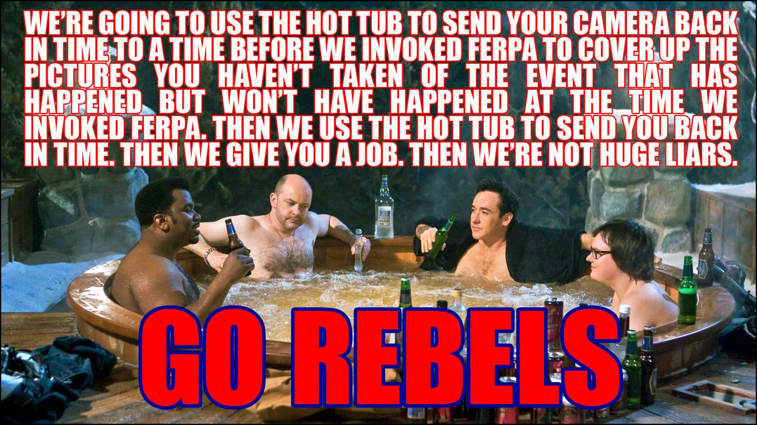

Furthermore, FERPA regulates the activities of school employees and agents. Nothing a non-employee student can do on his or her own can violate anyone’s FERPA rights, ever.
So, Director of Public Relations Danny Blanton, you took a law that was inapplicable to the group of people you were addressing, applied to records it doesn’t cover and that don’t even exist, and used that to avoid any pictures of your mandatory don’t-be-a-bigot session.
(This isn’t really part of the FERPA stuff, but is requiring people to show up to what is essentially a class the best idea you’ve had for how to stop people yelling bigoted stuff at Ole Miss? You give everybody in the room detention, basically? I wouldn’t go to Ole Miss just because I don’t want to accidentally be in the room when someone else is a bigot and says something and ends up screwing up my Thursday night plans. Because, come on, the odds of there not being a bigot in an auditorium in Mississippi feels kind of remote.)

Is this what they taught you at Ole Miss? When there’s absolutely no right to get the thing you want, make stuff up out of thin air? And it’s not even a good lie. That’s the kicker. Lying is selfish, but using stupid lies is disrespectful.

Can somebody at Ole Miss please hold a mandatory reeducation session for Danny Blanton on the evils of dumb lies? I promise not to take pictures.

Even though FERPA wouldn’t apply.

Scenario 4:

You hear about a report of a pellet gun fight in an apartment complex in your city. You hear the local police department arrested the two students involved. Knowing open records law, you decide to go to the police station and ask for the report. The police department refuses to turn over the police report — and the person at the desk cites FERPA.

What do you do?

Scenario 4 answer:

School says police report about pellet gun shooting is protected by FERPA

After learning of a fight at an apartment complex involving a pellet gun, The Butler Collegian asked the Butler University Police Department for a copy of the incident report. The police department declined to turn over the police report, citing FERPA. When questioned further, the police department said the incident report was not a law enforcement record because the case had been referred to Butler’s student affairs department.

Source: The Butler Collegian, Suspect name not released in incident (Sept. 19, 2012).

SPLC Executive Director Frank LoMonte: This one’s not even close.
When the police respond to the scene of a reported crime (in this case, an assault) and create a writeup, that’s a law enforcement record, not an “education record.”

Congress specifically amended FERPA in 1992 to exclude “records maintained by a law enforcement unit of the educational agency or institution that were created by that law enforcement unit for the purpose of law enforcement” from the definition of confidential FERPA records. See 20 U.S.C. Sec. 1232g(a)(4)(B).

We constantly hear the excuse that, even if police initially created the record for law enforcement purposes, it magically transforms into an education record if the decision is made to handle the crime as a disciplinary case and not a criminal case. Follow that logic, if you can.

What happens if the student who got shot by the pellet gun changes his mind and decides, two weeks later, that he wants to press criminal charges after all? Does the report then magically revert back to being a law enforcement record? Or what if the district attorney learns of the crime and decides campus discipline isn’t enough punishment and opens a criminal investigation — does the report then magically transform into a law enforcement record? You see how silly this could get.

What matters under FERPA is the purpose for which the record was created, not the manner in which it is later used. In this case, police with full state-delegated arrest authority responded to investigate a report of a violent crime. That’s a law enforcement activity, period.

The purpose of exempting law enforcement records from FERPA is to allow students to take precautions against crime to keep themselves safe. So it makes no sense to treat a burglary differently just because it is punished with a suspension rather than jail time. (“Oh, I heard a car got broken into last week, but that was just a disciplinary burglary, so I guess I’ll leave my MacBook right here on the passenger seat.”)

Police reports are never FERPA records, period.

(As a bonus, Butler police also claimed they’re exempt from the Indiana Access to Public Records Act because the university, being private, isn’t a state agency. But the Butler University Police Department is different. Its website boasts that Butler police officers “are appointed under the statutes of the State of Indiana with full police power and are available 24 hours a day throughout the year.” Those Indiana statutes give police officers at private colleges “[g]eneral police powers, including the power to arrest” and “[t]he same common law and statutory powers, privileges and immunities as sheriffs and constables.” When you ask for state authority to carry out a state function, you’d best be prepared to accept the disclosure responsibilities that go along with it.)

We rate this:

