Name: ______________________________ Date: ______________________

P.E. Photo Assignment

Today you will be going to a P.E. class to practice taking sports photos. Make sure you do not disrupt the class by getting in their way. Follow any directions the teachers tell you.

You need to shoot THREE of the following types of photos:
ACTION SHOT RULE OF THIRDS LEADING LINES
FRAMING BIRDS EYE VIEW WORMS EYE VIEW

Whichever three types you choose, you need to turn in two photos for each type. So, you will turn in six photos total.

Common Sports Photo Problems
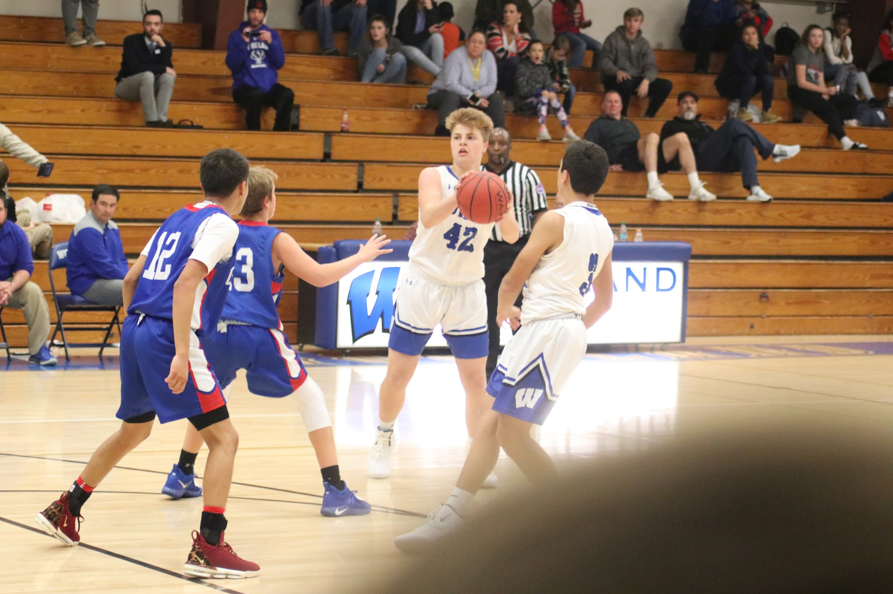
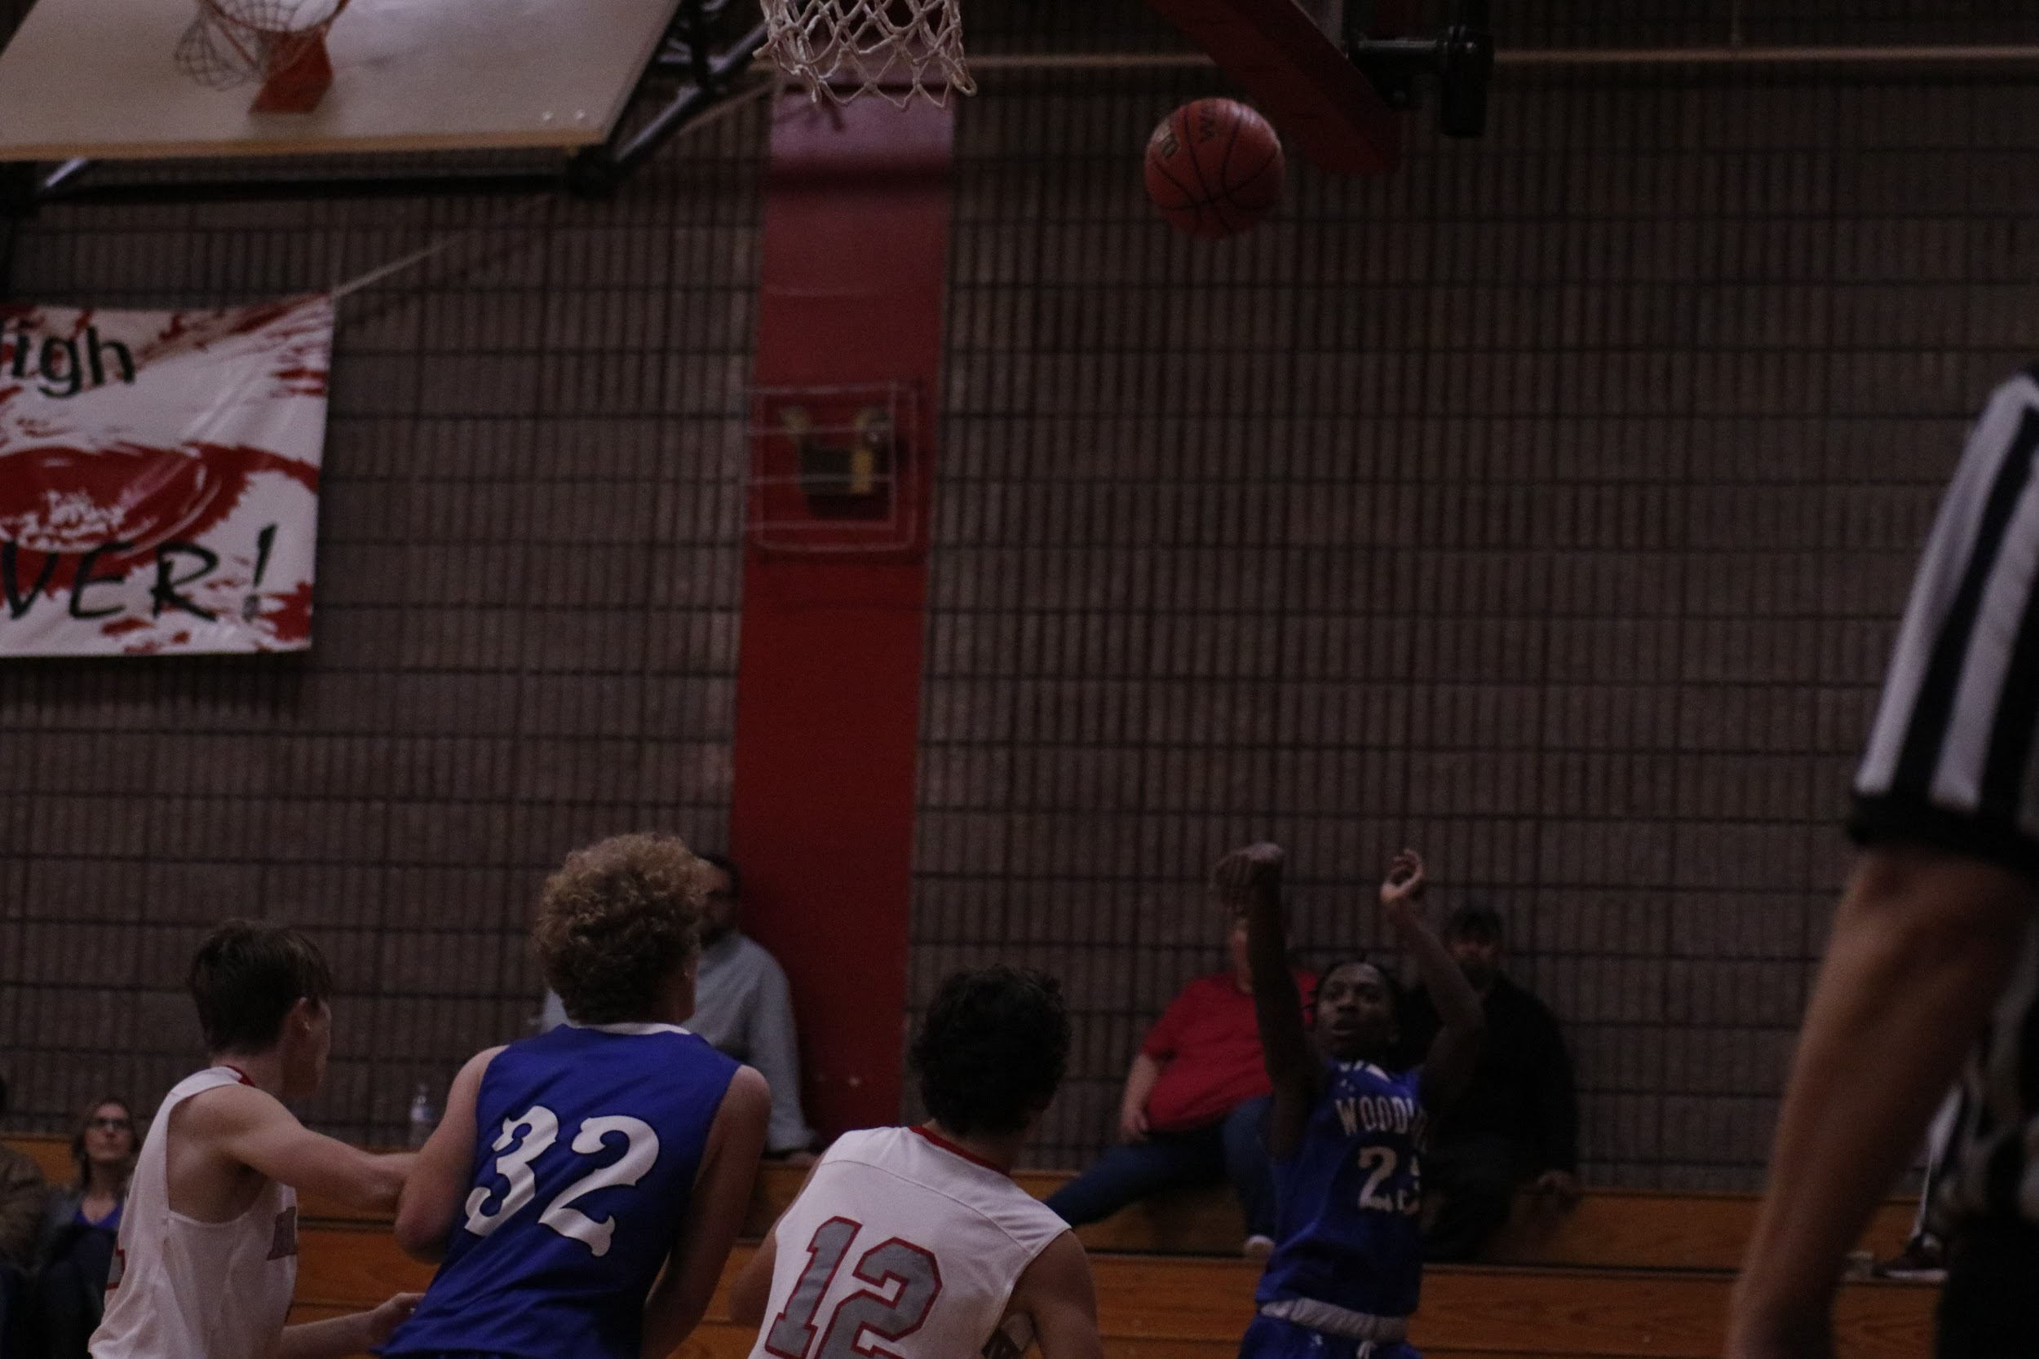

Under exposed

Over exposed

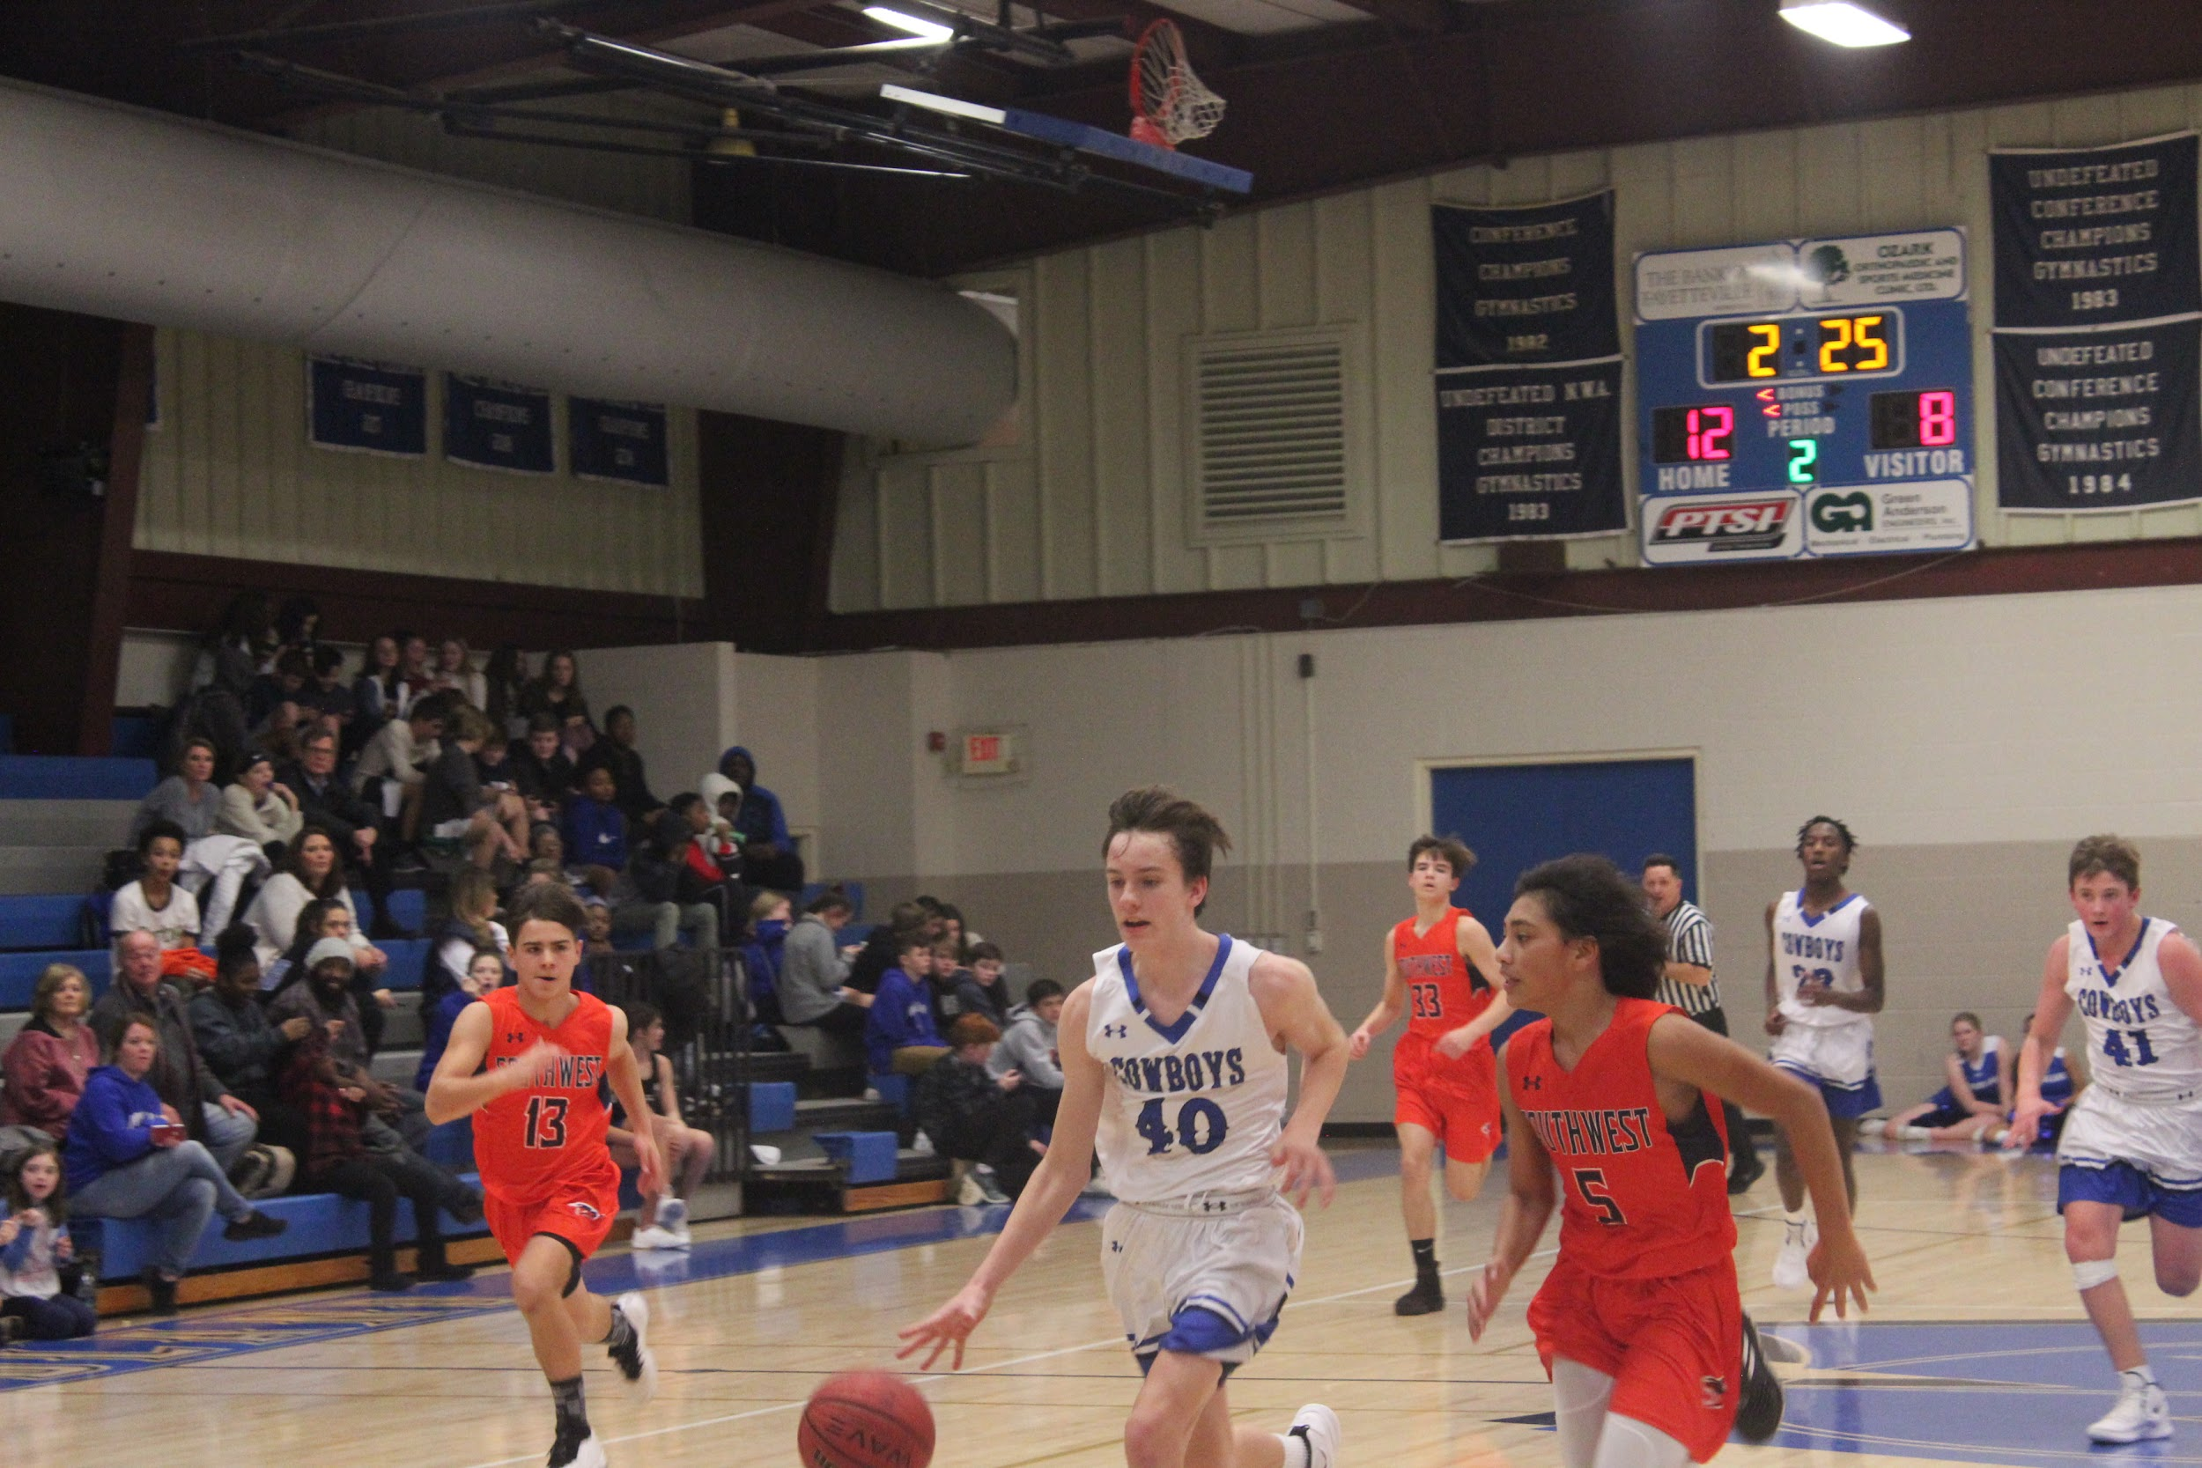
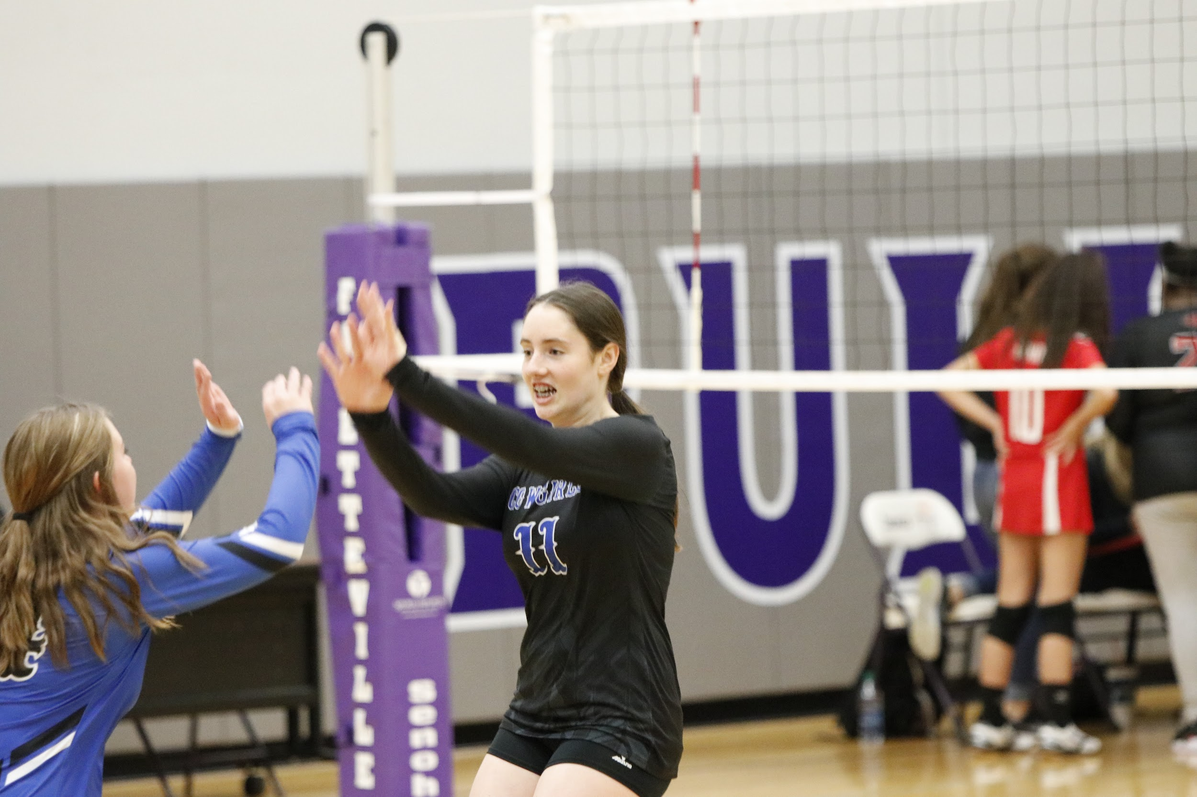

Cut off basketball
& limbs

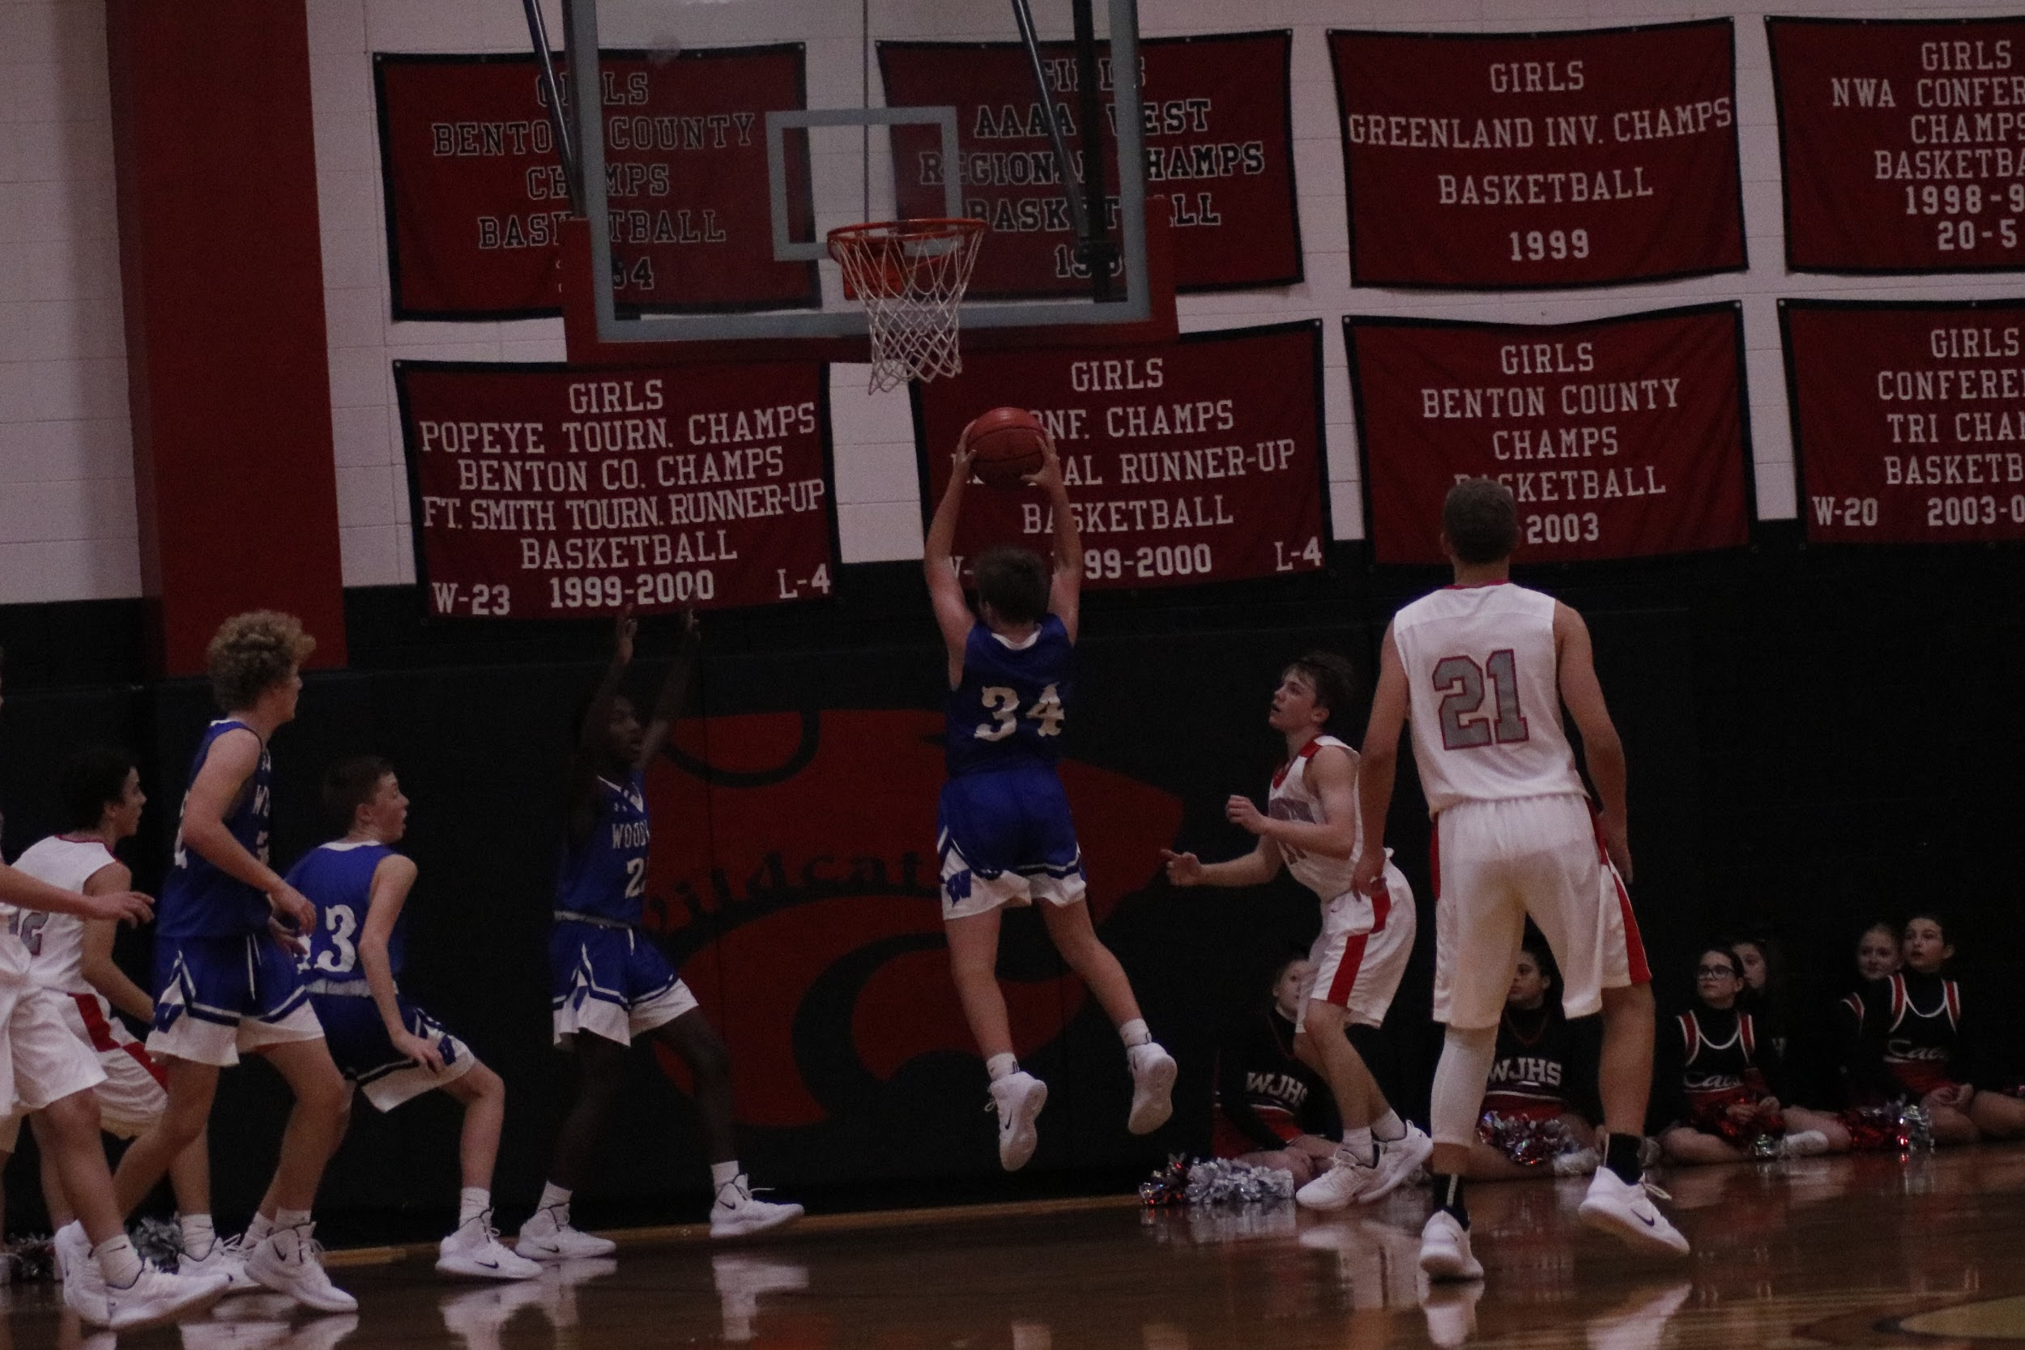
Blurry
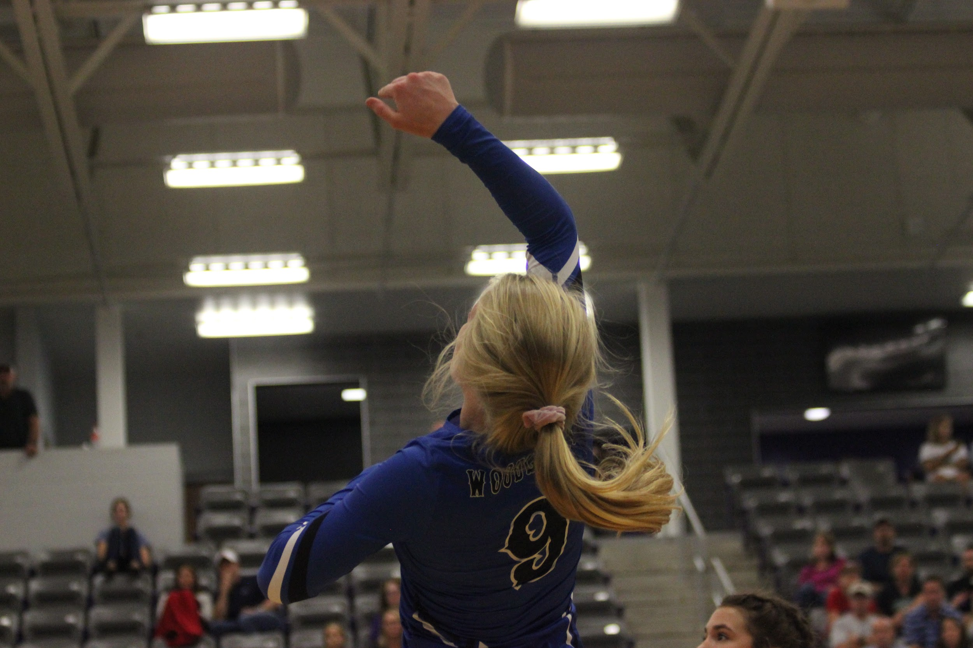

Cannot see
faces
Cannot
see face
or the ball

