Caption Writing Practice Name: ___________________________________
For each photo, write a photo caption & headline using the rules you have learned. Note: All identifying information for these photos is fictional.
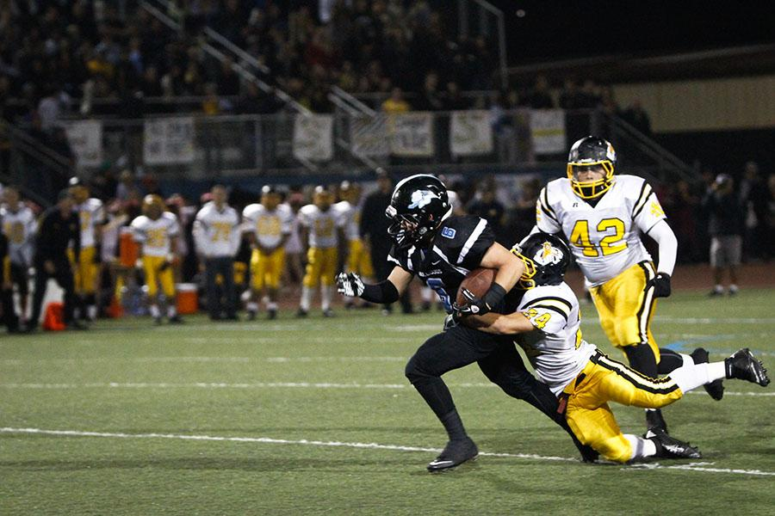
Who: senior running back John Smith
What: gets first down
Where: home game against Arlington High School
When: last Friday
Why:

Write an expanded yearbook caption with quote:

Who: junior quarterback Alex Rodriguez
What: gets treated by the trainer
Where: Dublin High School
When: district playoff game
Why: late tackle after a pass

Write a newspaper caption:

Who: student section members
What: celebrate
Where: Hayes High School stadium
When: during homecoming game Oct 20
Why: after touchdown against rival team

Write an expanded yearbook caption:

Now, go through the brainstorming process yourself to write captions for the following photos.

Who:
What:
Where:
When:
Why:

Write a yearbook summary caption:

Who:
What:
Where:
When:
Why:

Write an extended yearbook caption with quote:

Who:
What:
Where:
When:
Why:

Write a newspaper caption:

Who:
What:
Where:
When:
Why:

Write a yearbook summary caption:

Who:
What:
Where:
When:
Why:

Write a newspaper caption:

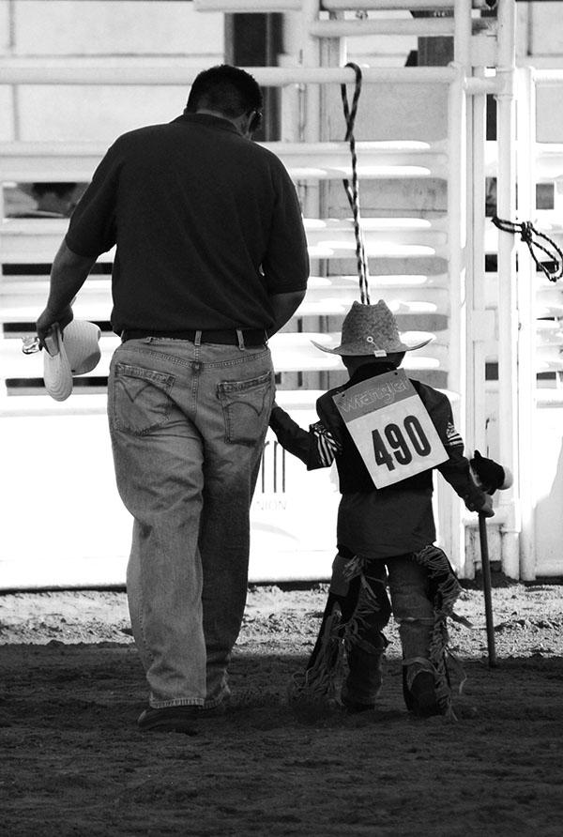

Who:
What:
Where:
When:
Why:

Write an extended yearbook caption with quote:

