Name __________________________

Choosing Photos for Publication: Homework Assignment

- How did your group make decisions about the paper’s content? What factors did you consider?

- In what ways did the class discussion influence your thoughts about your group’s decisions?

- Look at the two sample designs on the back of this handout. In what ways is the message and content different between the two designs? Is one paper more professional? Why?

- Compare your own design (which should be sketched on the design template you received in class) to the two sample designs. Discuss any changes you would make to your own design after today’s lesson and discussion.

- Look at the “questions to consider” from today’s lesson (they are also included below). Which of these questions resonates with you as a journalist most strongly? Explain.

- In the space below, summarize your learning from today’s activity. Be sure to answer the following questions: In what ways does a newspaper’s visual content impact the message communicated to a reader? What should a journalist do because of it?

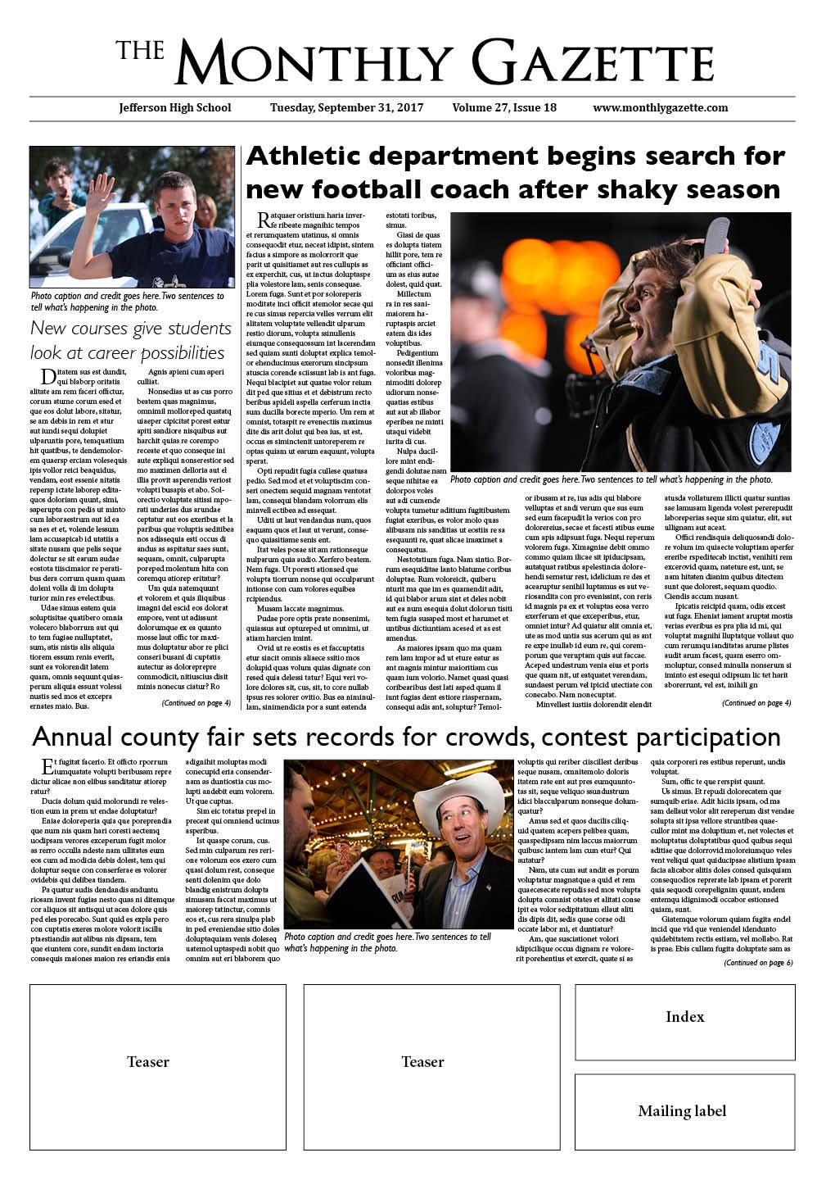

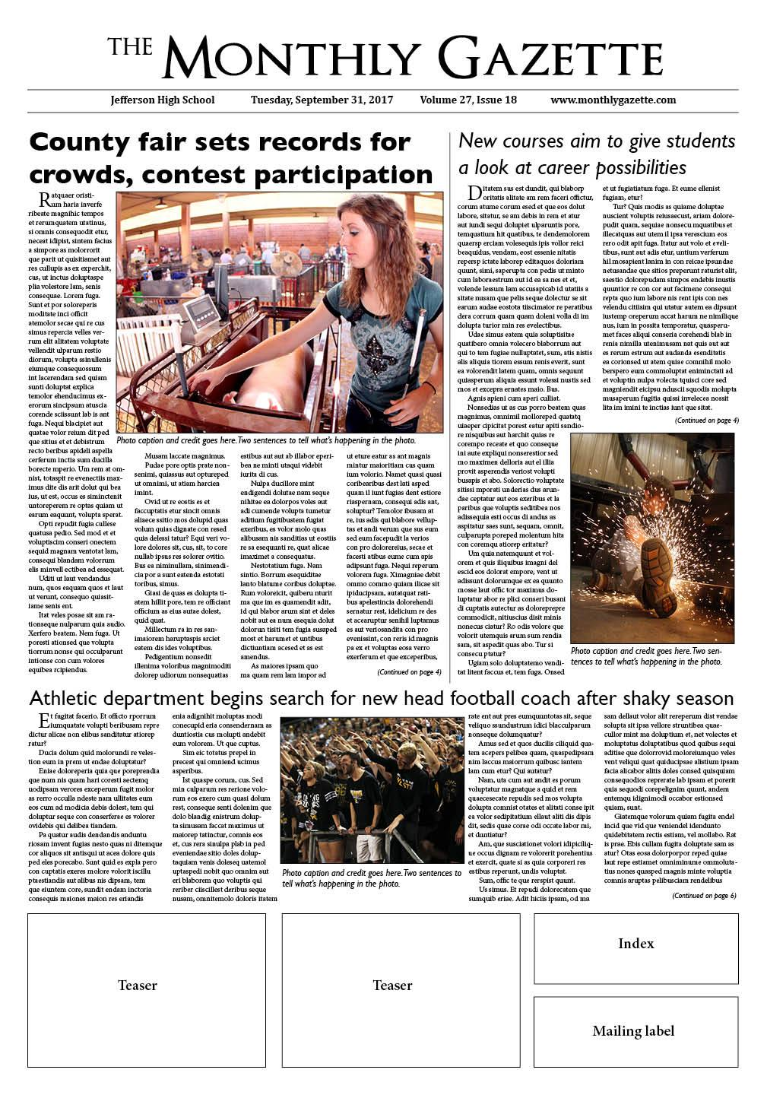
Design #1
Design #2

