Photojournalism Exam Name ________________________

Part 1: Match the photography term with its definition.
_____ 1. Framing A. Composition technique by which lines direct viewers to the subject
_____ 2. Metering B. Photo with the background cut away, leaving only subject
_____ 3. Burn C. Color correction tool that allows for very specific areas of correction
_____ 4. ISO D. Length of time a camera allows light into the camera’s eye
_____ 5. Manual mode E. Special file type that allows for advanced photo editing
_____ 6. Levels F. Composition technique using a repeating element or pattern
_____ 7. Rule of thirds G. Natural adjustment camera makes to adjust for different light sources
_____ 8. White balance H. Multiple photos working together to deliver one cohesive message
_____ 9. Dodge I. Color correction tool with all bright or dark areas are controlled at once
_____ 10. Aperture J. A general term for the amount of light that reaches a camera’s lens
_____ 11. Leading lines K. Photo angle from extreme high vantage point
_____ 12. Focal point L. Editing tool that allows specific areas of a photo to be made darker
_____ 13. RAW M. Composition rule; the photographer is above or below subject
_____ 14. Selective focus N. Camera setting where the photographer controls all aspects
_____ 15. Shutter speed O. Artificial light added to a photo
_____ 16. Photo story P. The amount of light that enters through the camera’s eye
_____ 17. Worm’s eye view Q. Composition rule; subject is not centered in the photo
_____ 18. Cropping R. Editing tool that allows specific areas of a photo to be made lighter
_____ 19. Angles S. Photo’s subject or center of interest
_____ 20. JPEG T. Photo taken from extreme low vantage point
_____ 21. Exposure U. How much of the viewfinder the camera uses to determine exposure
_____ 22. Flash V. File type that is most common for saving edited photographs
_____ 23. Cutout W. Composition rule; subject is clear while other images appear blurry
_____ 24. Repetition X. The removal of outer parts of an image to improve the overall photo
_____ 25. Curves Y. Camera’s sensitivity to light
_____ 26. Bird’s eye view Z. Composition technique in which elements frame the subject

Part 2: Match the individual with the task for which he/she is famous.
_____ 27. Louis Daguerre A. Coined the term “photojournalism”
_____ 28. Carol Szathmari B. Civil War photographer accused of moving
bodies
_____ 29. George Eastman C. Published first illustrated book
_____ 30. Frank Luther Mott D. Took pictures of a galloping horse
_____ 31. Mathew Brady E. Lincoln gave him permission to photograph
the Civil War
_____ 32. Alexander Gardner F. Photographer of famous “Migrant Mother”
_____ 33. Dorothea Lange G. First photojournalist - pics of Crimean War
_____ 34. Eadweard Muybridge H. Created an exposure in 30 seconds
_____ 35. William Henry Fox Talbot I. Developed the first roll of film for a camera

Part 3: Answer each of the following questions on a separate sheet of paper: (2 pts each)
36-37. List and explain two tips for taking better portraits.

38-39. Describe action versus reaction when it comes to taking sports photos. Why does a photographer need both?

40-41. Describe how shutter speed affects a photograph. What does a photo taken with a slow shutter speed look like compared to a photo taken with a fast shutter speed?

42-43. Explain the white balance setting. Describe how you might decide which setting to use.

44-45. What is the purpose of taking photos in RAW form instead of JPEG?

46-47. Put the following items in order from least effective to most effective when it comes to color correction, then explain: curves, brightness/contrast, levels.

48-49. Compare and contrast a cropped photo versus a cutout.

50-51. Imagine you are trying to take a photo in a dark hallway of the school. What are two tips that could use to improve the quality of your photo?

52-53. Name and explain two ethical considerations you think are important for photographers to follow.

54-55. Name two common photo manipulations that can get a photojournalist in trouble.

56-57. Describe two different ways a photographer might choose to capture motion.

58-59. In what ways can the visual content of a newspaper change the overall content of the newspaper for a viewer?

60-61. Explain the difference between news and features in photojournalism. How should a photojournalist prepare for these different types of photos?

Part 4: For each of the following photos, write a caption with headline that follows the guidelines given.
62-63: Newspaper caption.  (McKinney High School Publications) | 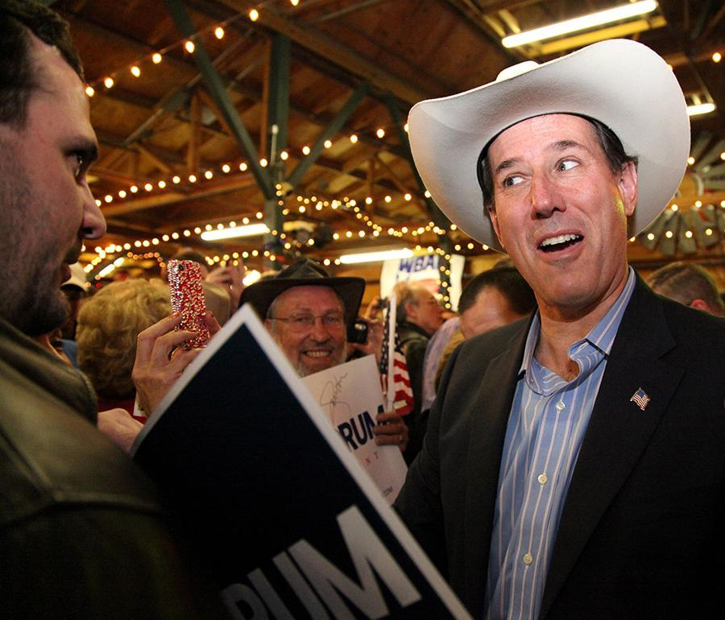
64-66: Yearbook extended caption w/ quote.

(Hannah Kunz - Westlake High School)
67-68: Yearbook summary caption.  (Lore Staff) | 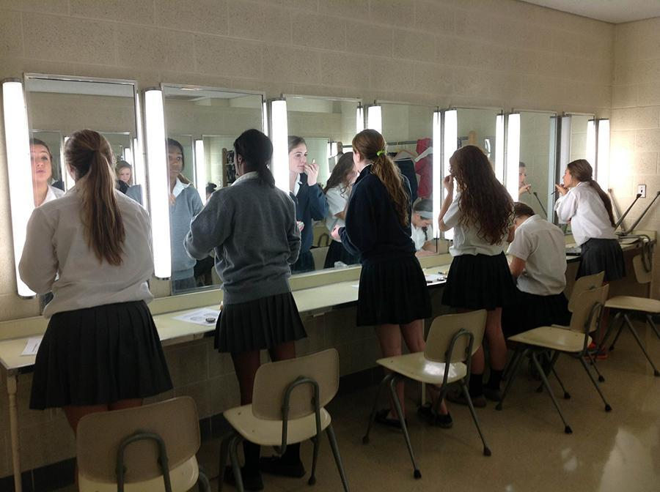

Part 5: For each of the following photos, name/explain one composition principle (focal point, framing, angle, leading lines, rule of thirds, selective focus, repetition) demonstrated. Do not use any term more than once.
69-70:

(Bryant High School Publications)
71-72:  (McKinney High School Publications) | 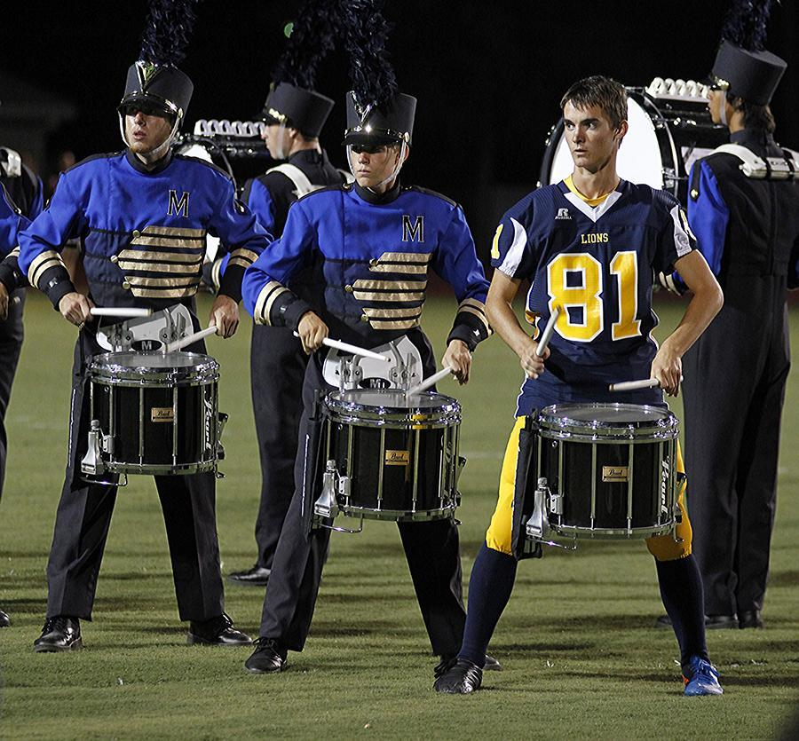
73-74:  (McKinney High School Publications) | 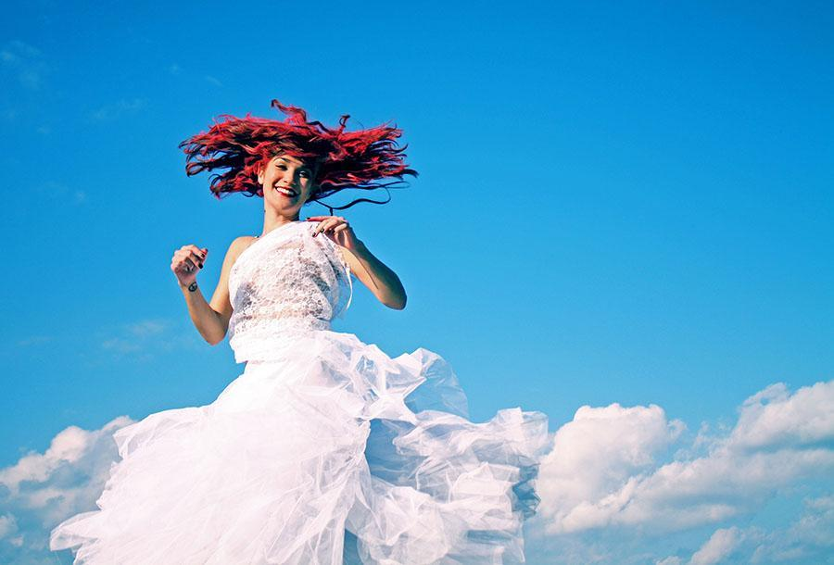
75-76:  (Peri Kincaid - Westlake High School) | 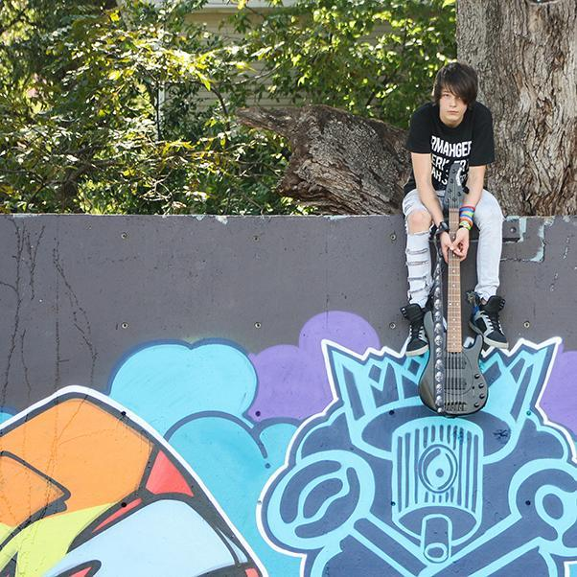
77-78:  (McKinney High School Publications) | 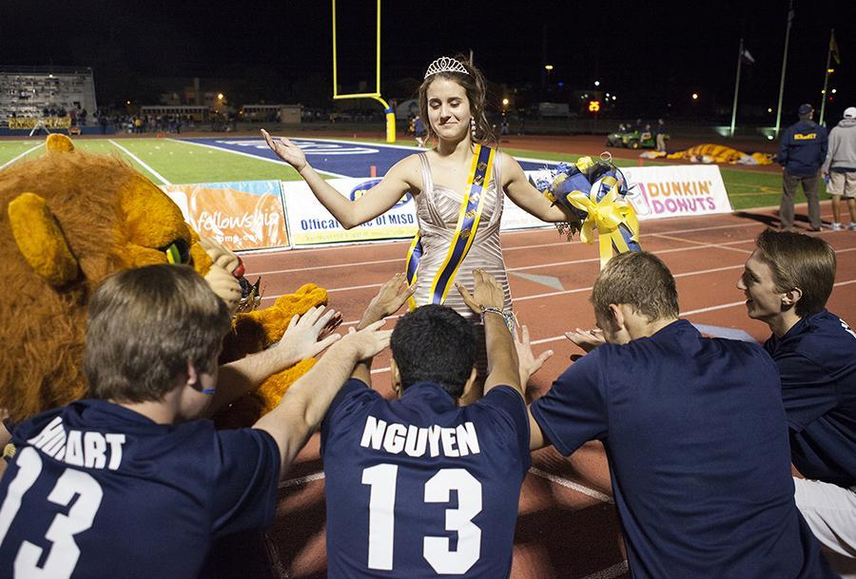

Part 6: Name one aspect of exposure (ISO, aperture, white balance, shutter speed, metering, flash) the photographer uses in the following photos and explain how it is done well.

79-81:  (Bryant High School Publications) | 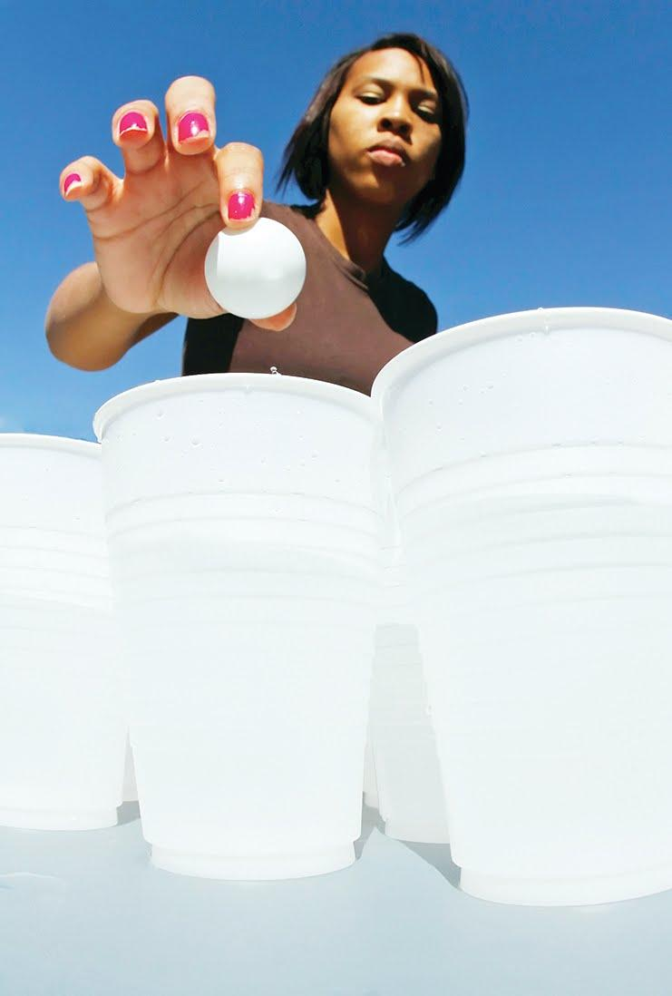
82-84:

(Bryant High School Publications)
85-87:

(Bryant High School Publications)
88-90:  (Casey Simmons - Westlake High School) | 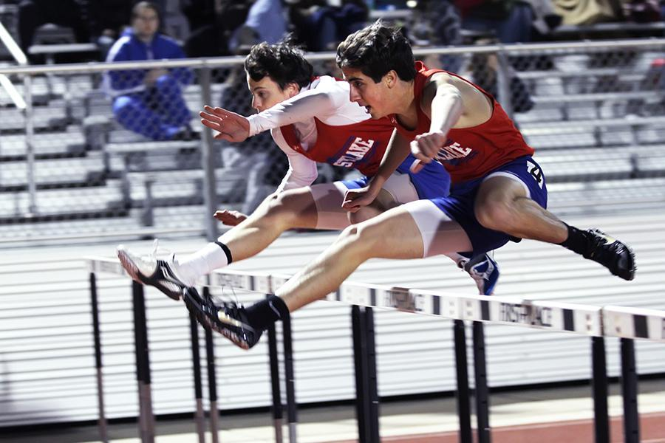
Part 7: Evaluate the photo story that is shown on the following page. How well do you think the photographer captures the essence of the story? Be specific and provide evidence to support your opinion. (10 points)

